VISVESVARAYA TECHNOLOGICAL UNIVERSITY
“JnanaSangama”, Belgaum -590014, Karnataka.

LAB REPORT
on
Artificial Intelligence (23CS5PCAIN)
Submitted by
SHASHANK SHANTHARAM NAYAK (1BM23CS313)
in partial fulfillment for the award of the degree of
BACHELOR OF ENGINEERING
in
COMPUTER SCIENCE AND ENGINEERING

B.M.S. COLLEGE OF ENGINEERING
(Autonomous Institution under VTU)
BENGALURU-560019
Aug 2025 to Dec 2025

B.M.S. College of Engineering,
Bull Temple Road, Bangalore 560019
(Affiliated To Visvesvaraya Technological University, Belgaum)
Department of Computer Science and Engineering

CERTIFICATE
This is to certify that the Lab work entitled “Artificial Intelligence (23CS5PCAIN)” carried out by SHASHANK SHANTHARAM NAYAK (1BM23CS313), who is bonafide student of B.M.S. College of Engineering. It is in partial fulfillment for the award of Bachelor of Engineering in Computer Science and Engineering of the Visvesvaraya Technological University, Belgaum. The Lab report has been approved as it satisfies the academic requirements in respect of an Artificial Intelligence (23CS5PCAIN) work prescribed for the said degree.

Dr. Seema Patil  Assistant Professor  Department of CSE, BMSCE | Dr. Kavitha Sooda  Professor & HOD  Department of CSE, BMSCE

Index
Sl.  No. | Date | Experiment Title | Page No.
1 | 30-9-2024 | Implement Tic –Tac –Toe Game  Implement vacuum cleaner agent | 4
2 | 7-10-2024 | Implement 8 puzzle problems using Depth First Search (DFS)  Implement Iterative deepening search algorithm | 12
3 | 14-10-2024 | Implement A* search algorithm | 30
4 | 21-10-2024 | Implement Hill Climbing search algorithm to solve N-Queens problem | 38
5 | 28-10-2024 | Simulated Annealing to Solve 8-Queens problem | 45
6 | 11-11-2024 | Create a knowledge base using propositional logic and show that the given query entails the knowledge base or not. | 49
7 | 2-12-2024 | Implement unification in first order logic | 57
8 | 2-12-2024 | Create a knowledge base consisting of first order logic statements and prove the given query using forward reasoning. | 63
9 | 16-12-2024 | Create a knowledge base consisting of first order logic statements and prove the given query using Resolution | 71
10 | 16-12-2024 | Implement Alpha-Beta Pruning. | 79

Github Link:
https://github.com/DevelSSN/1BM23CS313-SHASHANK-SHANTHARAM-NAYAK/tree/AI

Program 1
Implement Tic –Tac –Toe Game
Implement vacuum cleaner agent

Algorithm:
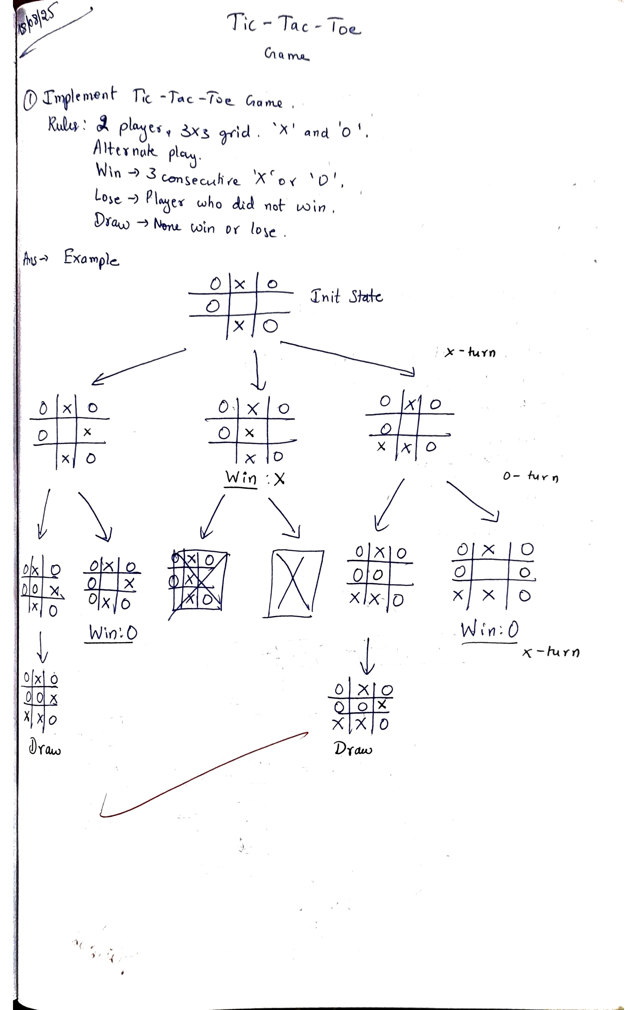
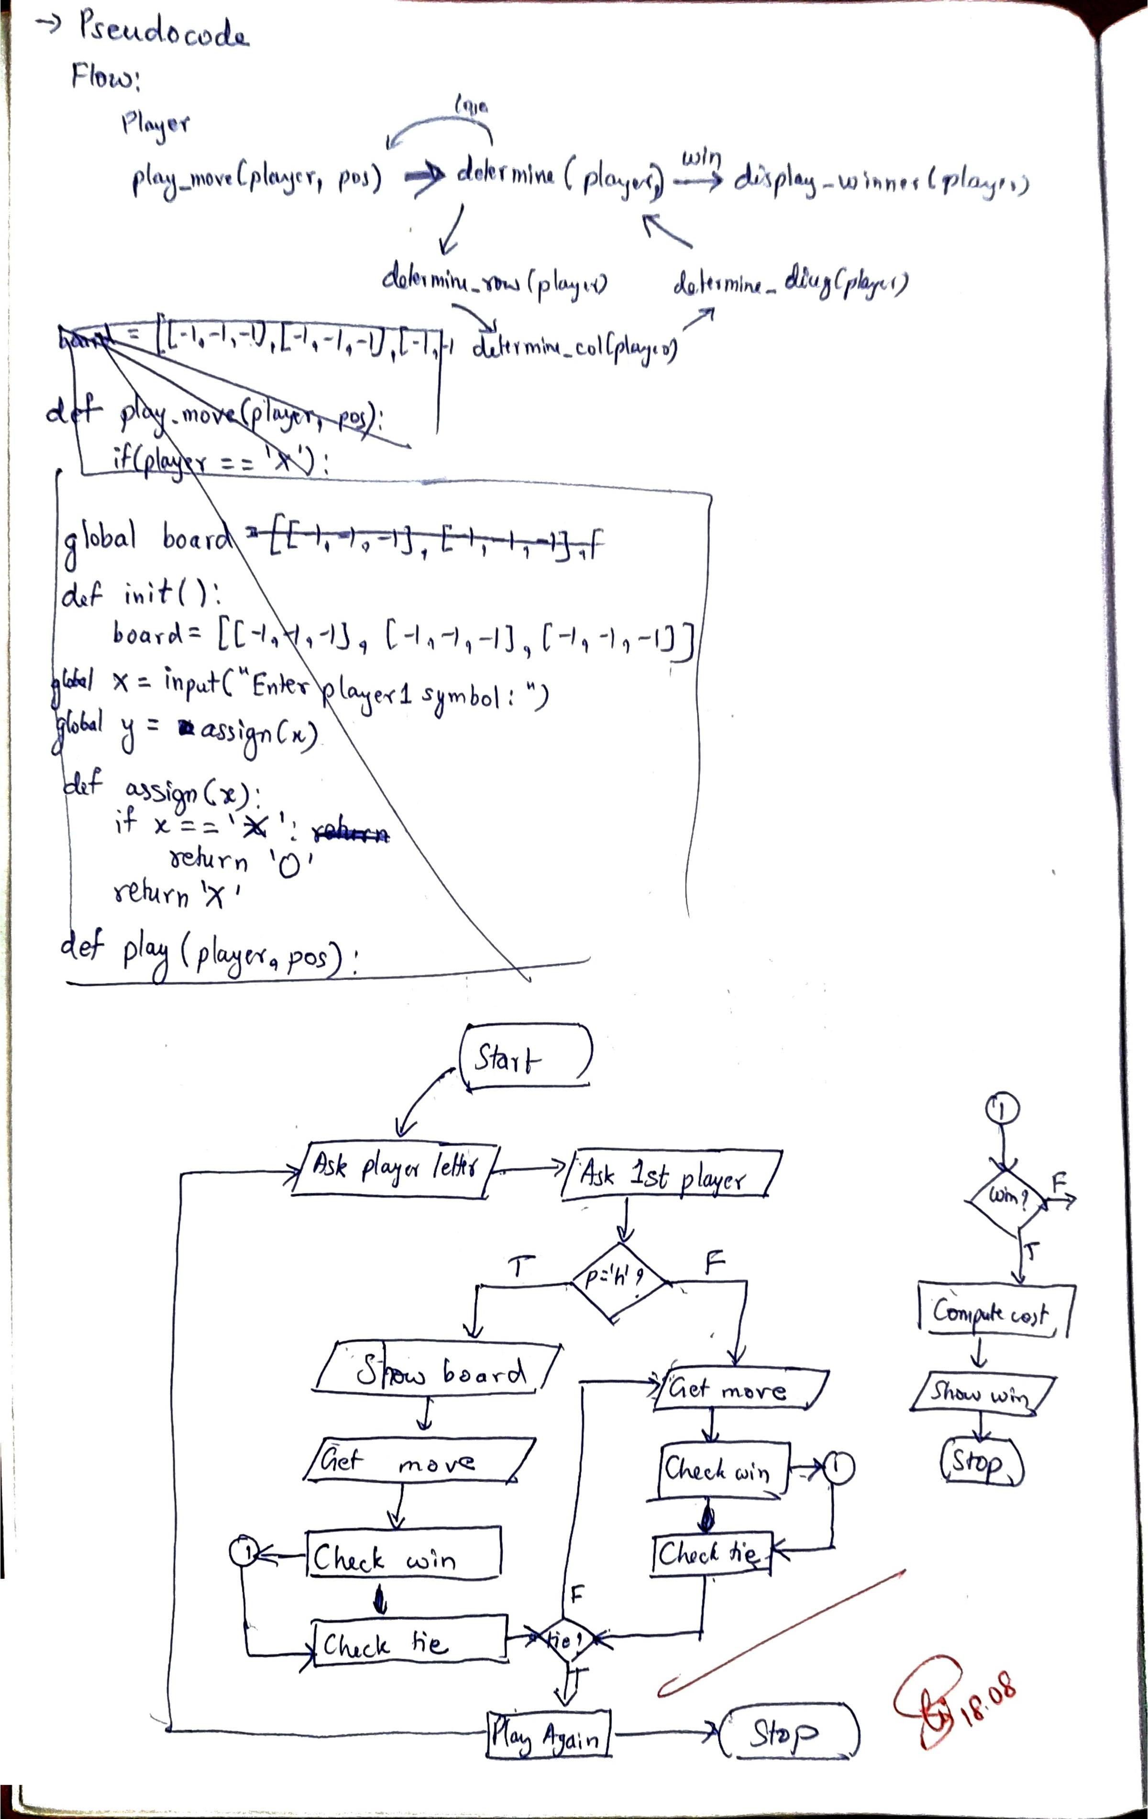
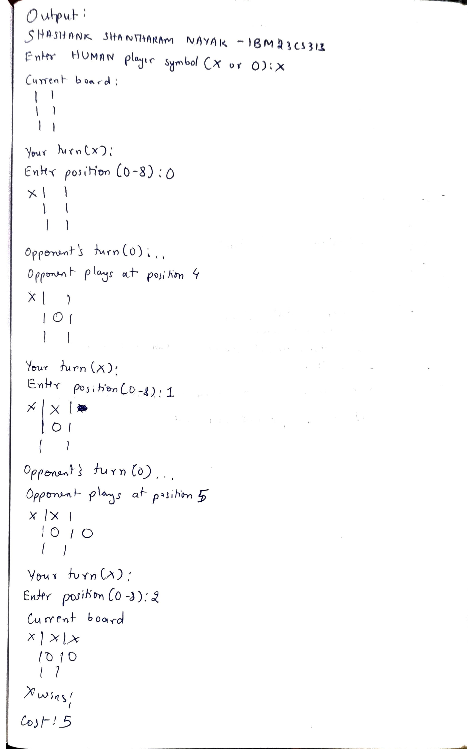

Code:
Tic-tac-toe

import random

def init():
global board
board = [[' ', ' ', ' '],
[' ', ' ', ' '],
[' ', ' ', ' ']]
global x
x = input("Enter HUMAN player symbol (X or O): ")
while x not in ['X', 'O']:
print("Invalid symbol! Please choose 'X' or 'O'.")
x = input("Enter HUMAN player symbol (X or O): ")
global y
y = assign(x)

def assign(x):
"""Assign opponent's symbol based on the human player's choice."""
return 'O' if x == 'X' else 'X'

def display_board():
"""Displays the current board state."""
print("\nCurrent Board:")
for row in board:
for cell in row:
print(cell, end="")
print('|', end="")
print()
print()

def valid_move(pos):
"""Check if the move is valid."""
if pos < 0 or pos > 8:
return False
row, col = pos // 3, pos % 3
return board[row][col] == ' '

def play(player, pos):
"""Make a move on the board."""
row, col = pos // 3, pos % 3
board[row][col] = player

def check_win():
"""Check if a player has won."""
for row in range(3):
if board[row][0] == board[row][1] == board[row][2] != ' ':
return True
for col in range(3):
if board[0][col] == board[1][col] == board[2][col] != ' ':
return True
if board[0][0] == board[1][1] == board[2][2] != ' ':
return True
if board[0][2] == board[1][1] == board[2][0] != ' ':
return True
return False

def is_draw():
"""Check if the game is a draw (board is full)."""
for row in board:
if ' ' in row:
return False
return True

def game():
init()
current_player = x # Human player starts
count = 0
while True:
display_board()
if current_player == x:
print(f"Your turn ({current_player}):")
move = int(input("Enter position (0-8): "))
while not valid_move(move):
print("Invalid move! Try again.")
move = int(input("Enter position (0-8): "))
else:
print(f"Opponent's turn ({current_player})...")
# For simplicity, we use a random move for the AI
# (this can be expanded)
move = get_random_move()
print(f"Opponent plays at position {move}")

play(current_player, move)
count += 1

if check_win():
display_board()
print(f"{current_player} wins!")
print(f"Cost:{count}")
break
elif is_draw():
display_board()
print("It's a draw!")
break

current_player = assign(current_player) # Alternate turns

def get_random_move():
"""Random move (for simplicity). This can be improved with AI logic."""
available_moves = [i for i in range(9) if valid_move(i)]
return random.choice(available_moves)

# Start the game
print("SHASHANK SHANTHARAM NAYAK - 1BM23CS313")
game()

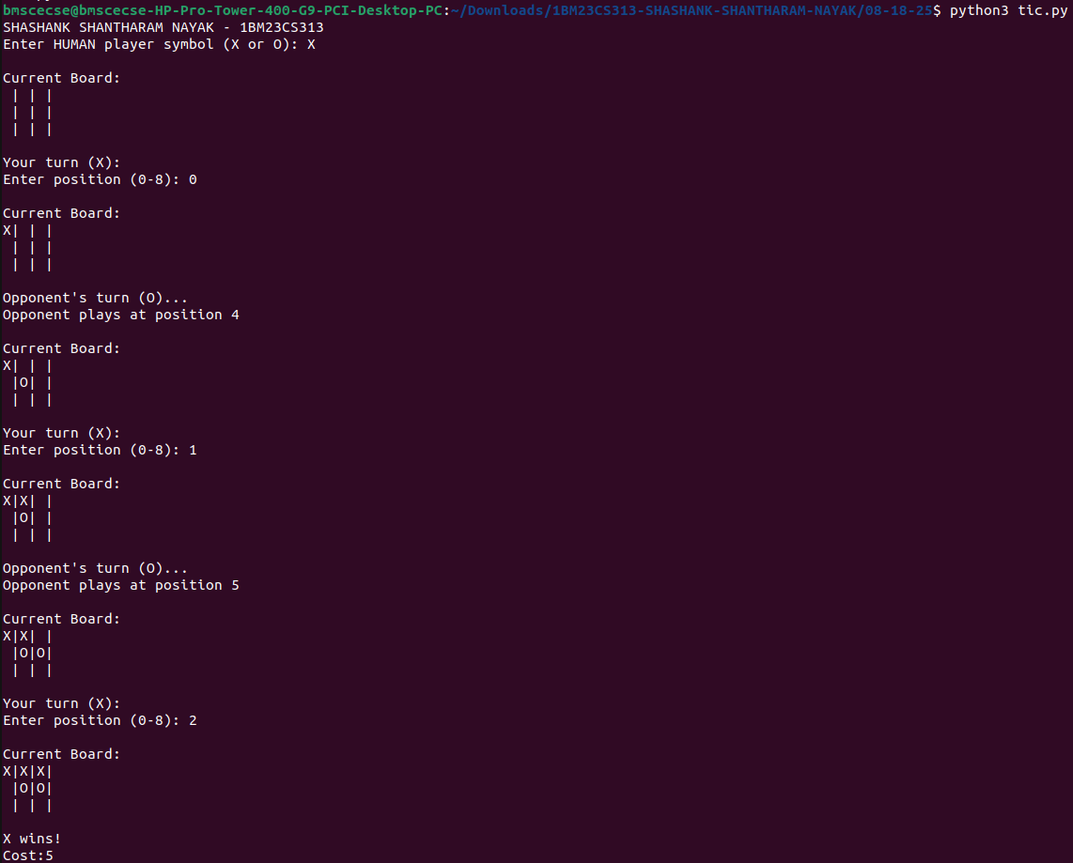

Vacuum cleaner
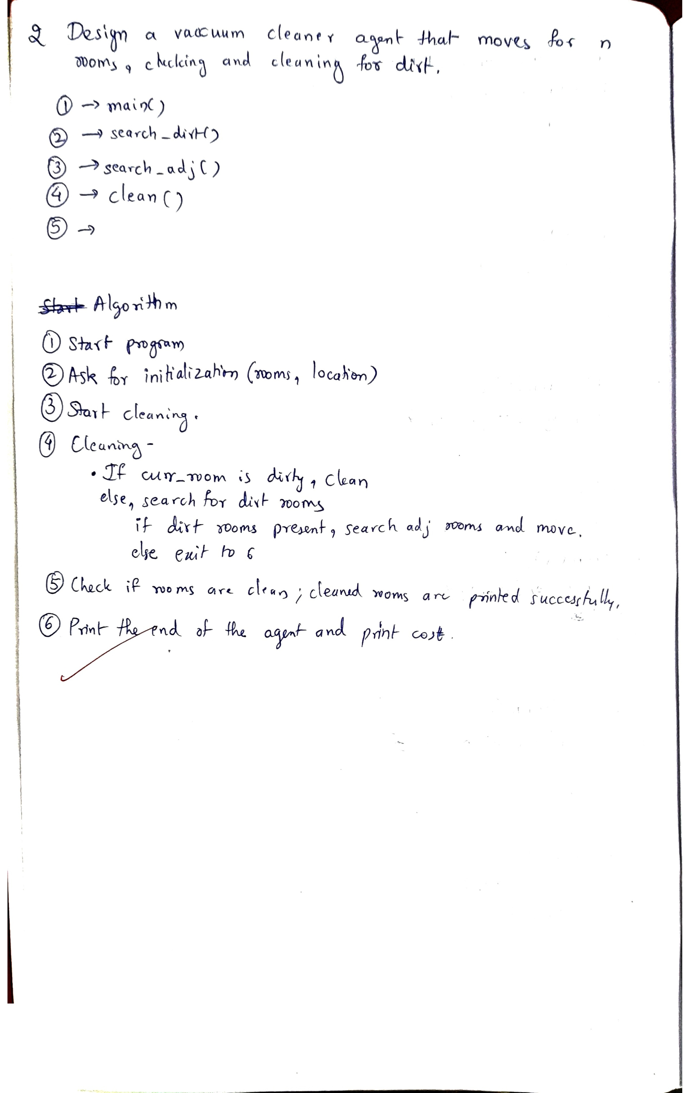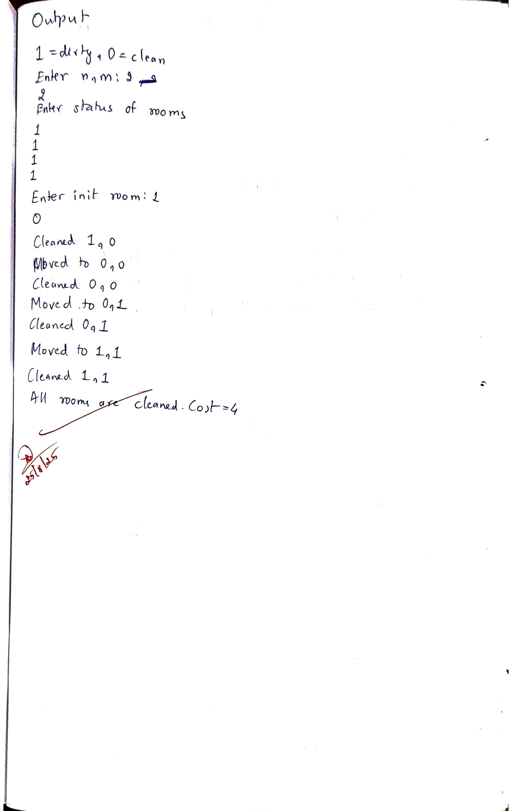
import random

def init():
global rooms
print("1=dirty 0=clean")
n, m = int(input("Enter n, m:")), int(input())
print("Enter the status of rooms")
rooms = [[int(input()) for x in range(m)] for y in range(n)]
global posx
global posy
posx, posy = int(input("Enter init room:")), int(input())

def searchDirty():
li = []
for i in range(len(rooms)):
for j in range(len(rooms[i])):
if rooms[i][j] == 1:
li.append((i, j))
return li

def searchAdj(i, j):
n = len(rooms)
m = len(rooms[0])
# Initialising a list where adjacent elements will be stored
ans = []
# Checking for all the possible adjacent positions
if isValidPos(i - 1, j, n, m):
ans.append((i-1, j))
if isValidPos(i, j - 1, n, m):
ans.append((i, j-1))
if isValidPos(i, j + 1, n, m):
ans.append((i, j+1))
if isValidPos(i + 1, j, n, m):
ans.append((i+1, j))

# Returning the list
return ans

def isValidPos(i, j, n, m):
if i < 0 or j < 0 or i >= n or j >= m:
return 0
return 1 and rooms[i][j] == 1

def clean(posx, posy):
print(f"Cleaned {posx}, {posy}")
rooms[posx][posy] = 0

def isClean():
for room in rooms:
for cell in room:
if cell == 1:
return False
return True

print("SHASHANK SHANTHARAM NAYAK - 1BM23CS313")
init()
count = 0
while not isClean():
count += 1
clean(posx, posy)
li = searchDirty()
if (len(li) == 0):
print(f"All rooms are clean. Cost={count}")
exit(0)
adj = searchAdj(posx, posy)
posx, posy = random.choice(adj)
print(f"Moved to {posx}, {posy}")

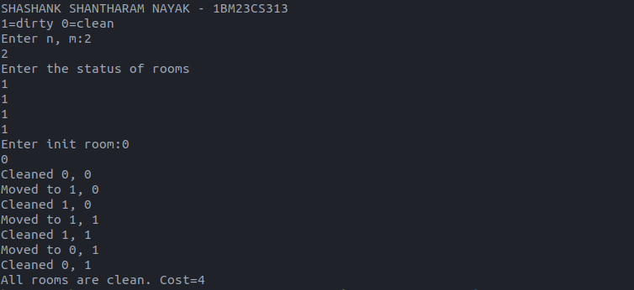
Github Link:
https://github.com/DevelSSN/1BM23CS313-SHASHANK-SHANTHARAM-NAYAK/tree/AI

Program 2
Implement 8 puzzle problems using Depth First Search (DFS)
Implement Iterative deepening search algorithm

Algorithm:
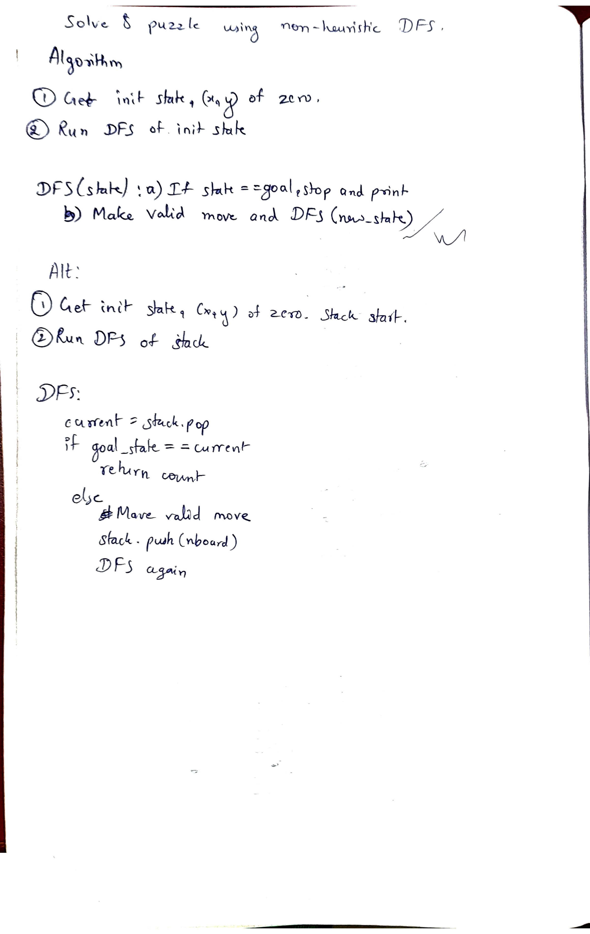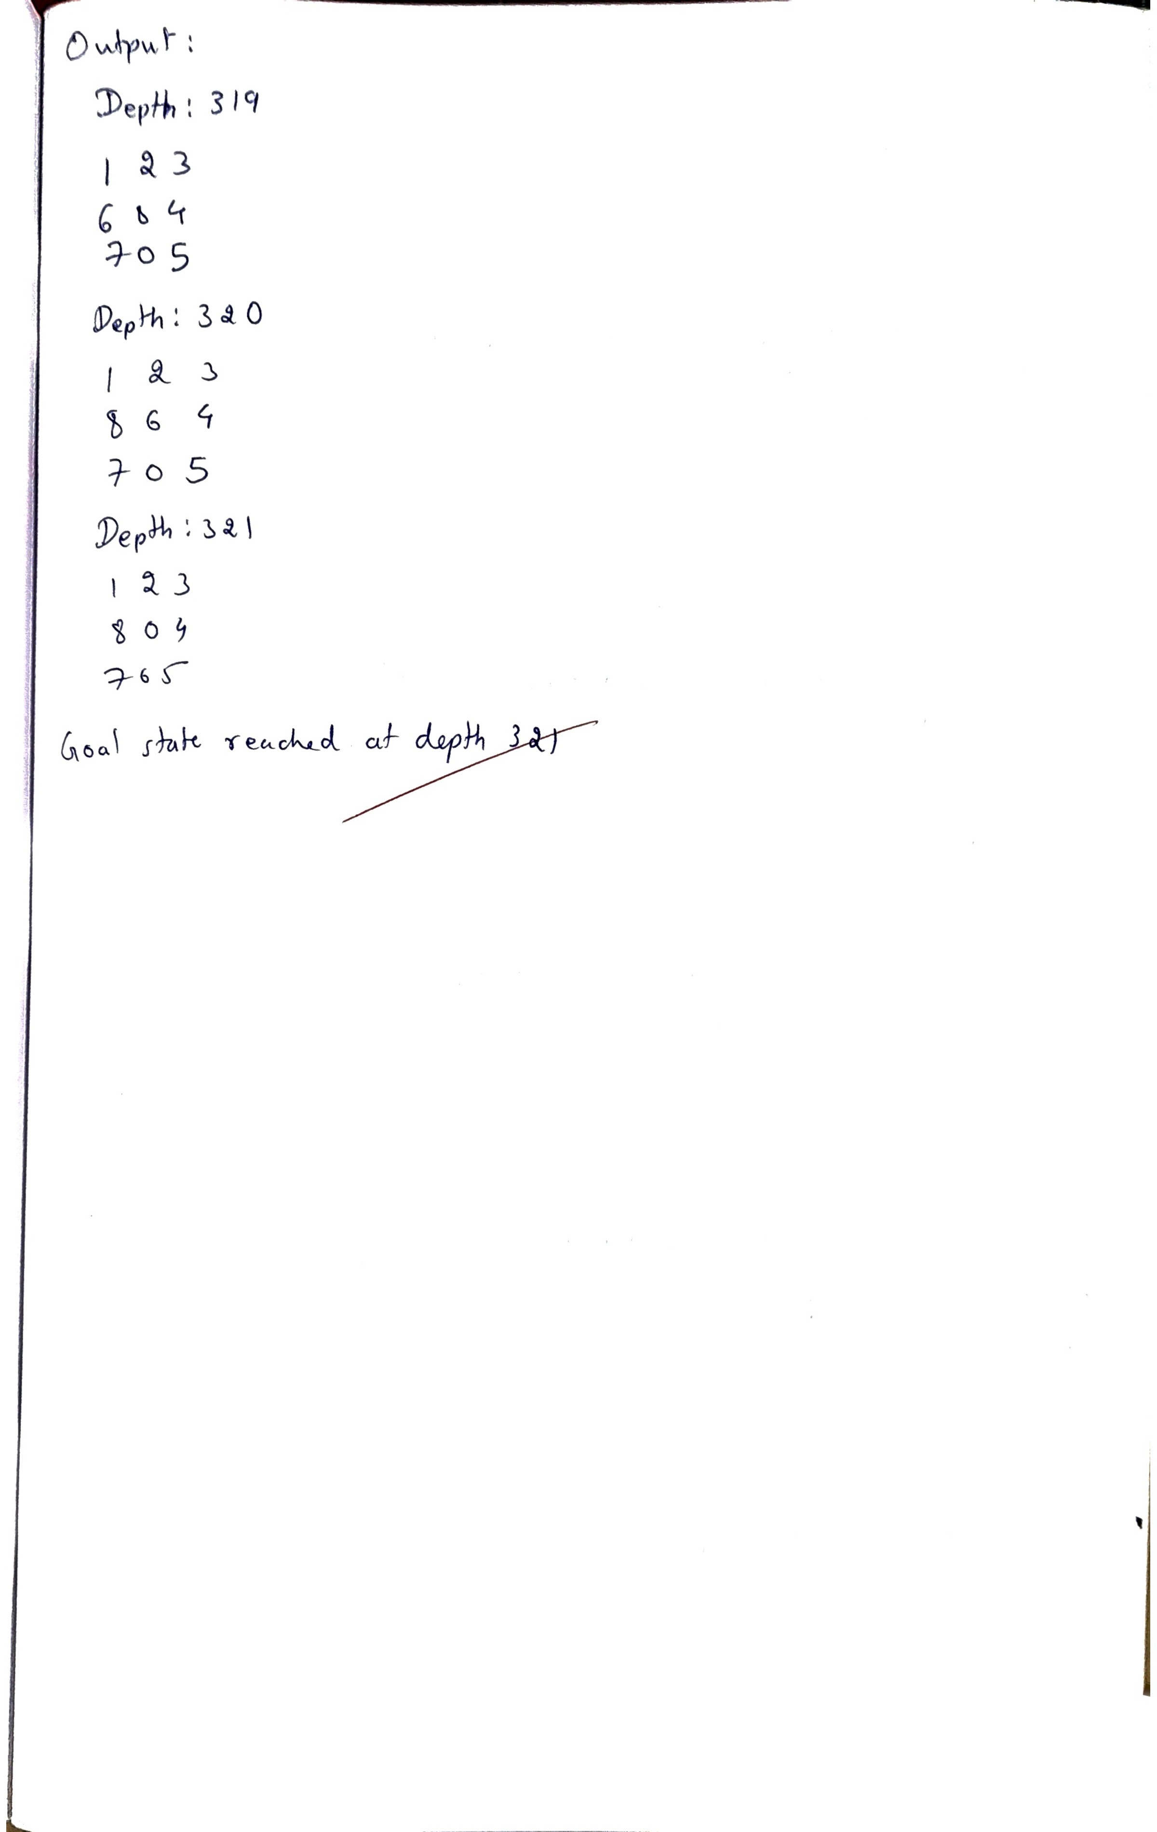

Code:
DFS
# Define the dimensions of the puzzle
N = 3

# Possible moves: Left, Right, Up, Down
row = [0, 0, -1, 1]
col = [-1, 1, 0, 0]

# Goal state definition
goal = (1, 2, 3, 8, 0, 4, 7, 6, 5) # Represent the goal state as a tuple

def is_goal_state(board):
return board == goal

def is_valid(x, y):
return 0 <= x < N and 0 <= y < N

def print_board(board):
# Convert tuple back to 2D list format for printing
for i in range(N):
print(' '.join(map(str, board[i * N:(i + 1) * N])))
print('--------')

def solve_puzzle_dfs(start, x, y, count, visited):
if is_goal_state(start):
print(f'Goal state reached at depth {count}')
print_board(start)
return count

# Explore all possible moves
for i in range(4):
nx = x + row[i]
ny = y + col[i]

if is_valid(nx, ny):
# Convert current 2D coordinates (x, y) to 1D index
current_index = x * N + y
next_index = nx * N + ny

# Create a new board configuration by swapping positions
new_board = list(start)
new_board[current_index], new_board[next_index] = new_board[next_index], new_board[current_index]
new_board_tuple = tuple(new_board)

# If this state has not been visited before, push it to the visited set and recurse
if new_board_tuple not in visited:
visited.add(new_board_tuple)

# Recursively search the next state
result = solve_puzzle_dfs(
new_board_tuple, nx, ny, count + 1, visited)
if result is not None: # If the goal state is found, propagate the result back
return result

print("Recurse back")
return None

if __name__ == '__main__':
print("SHASHANK SHANTHARAM NAYAK - 1BM23CS313")
print("Enter initial state:")

# Input initial state from user or hardcode the start
start = []
for i in range(N):
row = list(map(int, input(f"Enter row {i + 1}: ").split()))
start.extend(row) # Append row elements to the start list

# Convert start list to a tuple
start_tuple = tuple(start)

# Find position of 0 (empty space)
x, y = int(input("Enter x position of 0: ")), int(
input("Enter y position of 0: "))

print('Initial State:')
print_board(start_tuple)

# Set of visited states to avoid revisiting the same state
visited = set()
visited.add(start_tuple)

print("\nStart of Algorithm")
result = solve_puzzle_dfs(start_tuple, x, y, 0, visited)
if result is not None:
print(f"Solution found with depth {result}")
else:
print("No solution found")

IDS
# Define the dimensions of the puzzle
N = 3

# Possible moves: Left, Right, Up, Down
row = [0, 0, -1, 1]
col = [-1, 1, 0, 0]

# Goal state definition
goal = (1, 2, 3, 8, 0, 4, 7, 6, 5) # Represent the goal state as a tuple

def is_goal_state(board):
return board == goal

def is_valid(x, y):
return 0 <= x < N and 0 <= y < N

def print_board(board):
# Convert tuple back to 2D list format for printing
for i in range(N):
print(' '.join(map(str, board[i * N:(i + 1) * N])))
print('--------')

# Depth-limited DFS

def dfs_depth_limit(start, x, y, depth, limit, visited):
if depth > limit: # Depth limit exceeded, return None
return None

if is_goal_state(start): # Goal reached
print(f'Goal state reached at depth {depth}')
print_board(start)
return depth

# Explore all possible moves
for i in range(4):
nx = x + row[i]
ny = y + col[i]

if is_valid(nx, ny):
# Convert current 2D coordinates (x, y) to 1D index
current_index = x * N + y
next_index = nx * N + ny

# Create a new board configuration by swapping positions
new_board = list(start)
new_board[current_index], new_board[next_index] = new_board[next_index], new_board[current_index]
new_board_tuple = tuple(new_board)

# If this state has not been visited before, push it to the visited set and recurse
if new_board_tuple not in visited:
visited.add(new_board_tuple)

# Recursively search the next state with increased depth
result = dfs_depth_limit(
new_board_tuple, nx, ny, depth + 1, limit, visited)
if result is not None: # If the goal state is found, propagate the result back
return result

return None

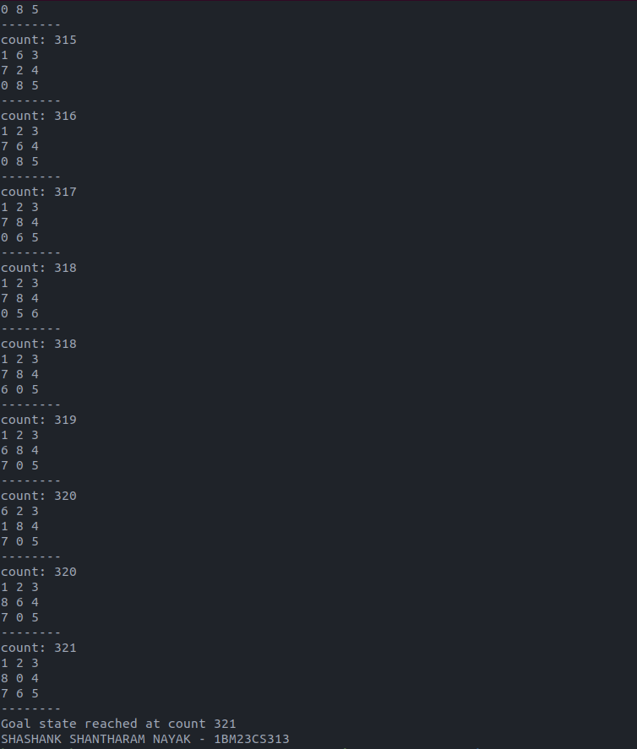

# Iterative Deepening Search

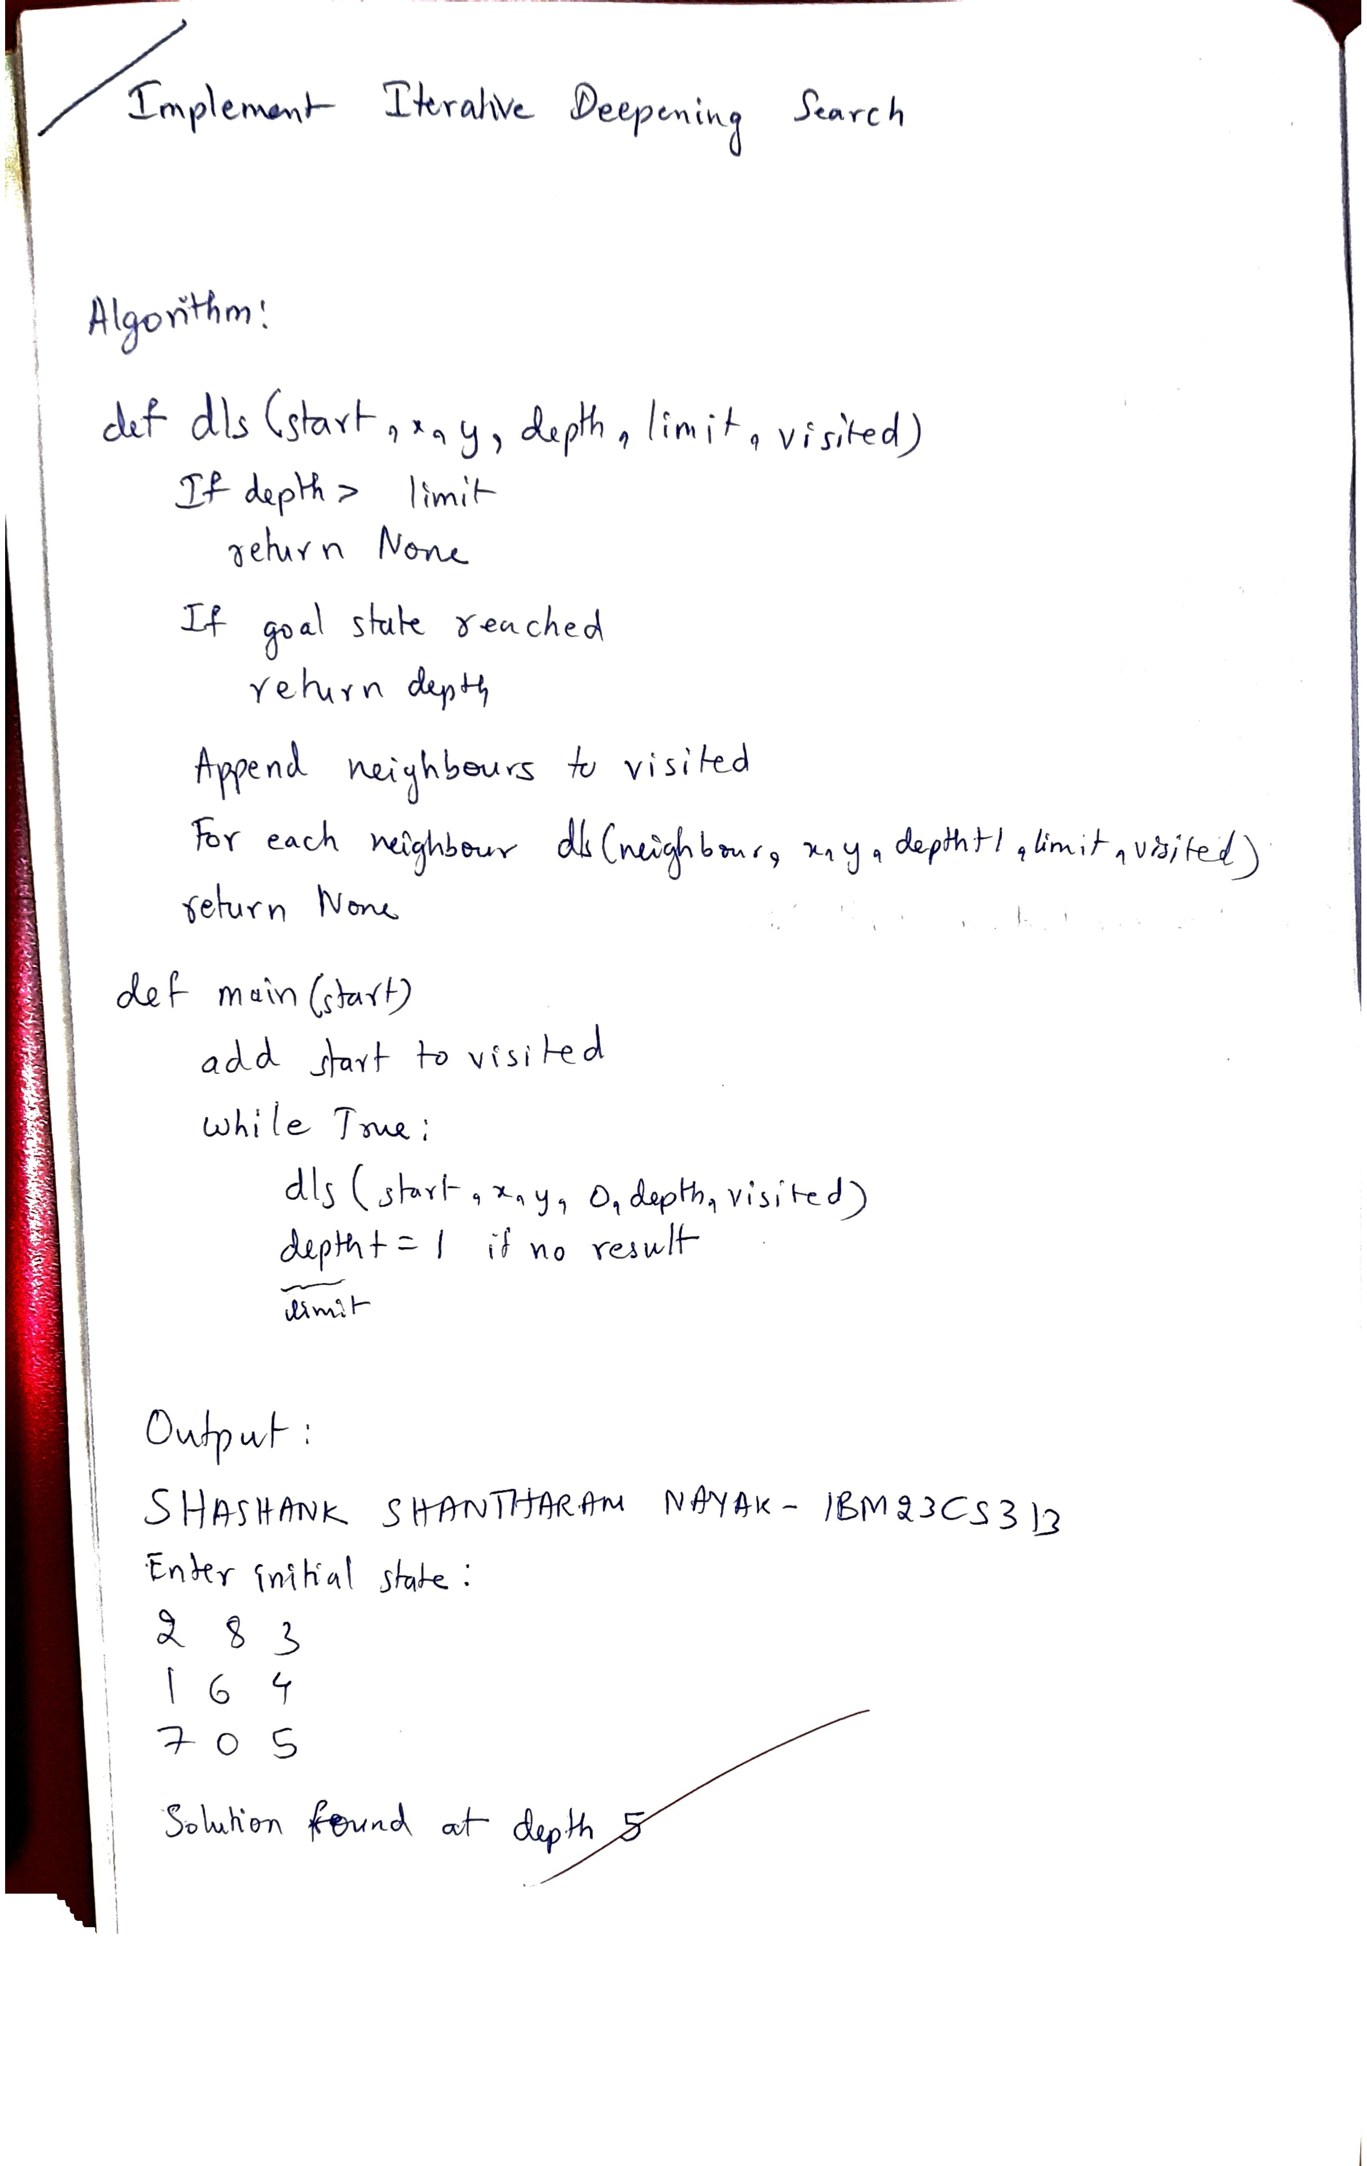

def iterative_deepening_search(start):
# Find the position of 0 (empty space)
x, y = start.index(0) // N, start.index(0) % N
visited = set()
visited.add(start)

depth = 0
while True:
print(f"Searching with depth limit {depth}")
result = dfs_depth_limit(start, x, y, 0, depth, visited)
if result is not None:
return result
depth += 1 # Increase the depth limit

if __name__ == '__main__':
print("SHASHANK SHANTHARAM NAYAK - 1BM23CS313")
print("Enter initial state:")

# Input initial state from user or hardcode the start
start = []
for i in range(N):
row = list(map(int, input(f"Enter row {i + 1}: ").split()))
start.extend(row) # Append row elements to the start list

# Convert start list to a tuple
start_tuple = tuple(start)

print('Initial State:')
print_board(start_tuple)

# Run Iterative Deepening Search
print("\nStart of Algorithm")
result = iterative_deepening_search(start_tuple)
if result is not None:
print(f"Solution found at depth {result}")
else:
print("No solution found")
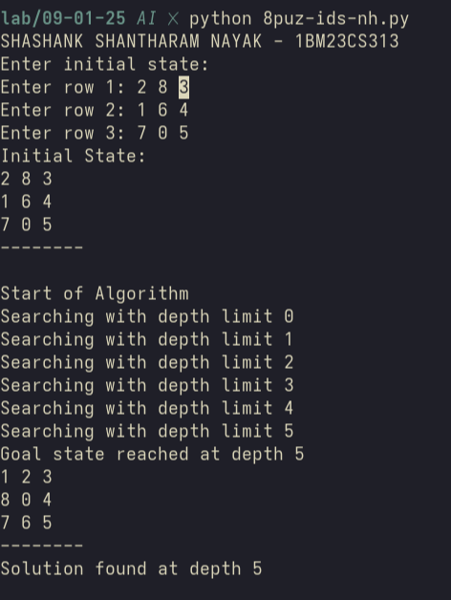
Github Link:
https://github.com/DevelSSN/1BM23CS313-SHASHANK-SHANTHARAM-NAYAK/tree/AI

Program 3
Implement A* search algorithm

Algorithm:
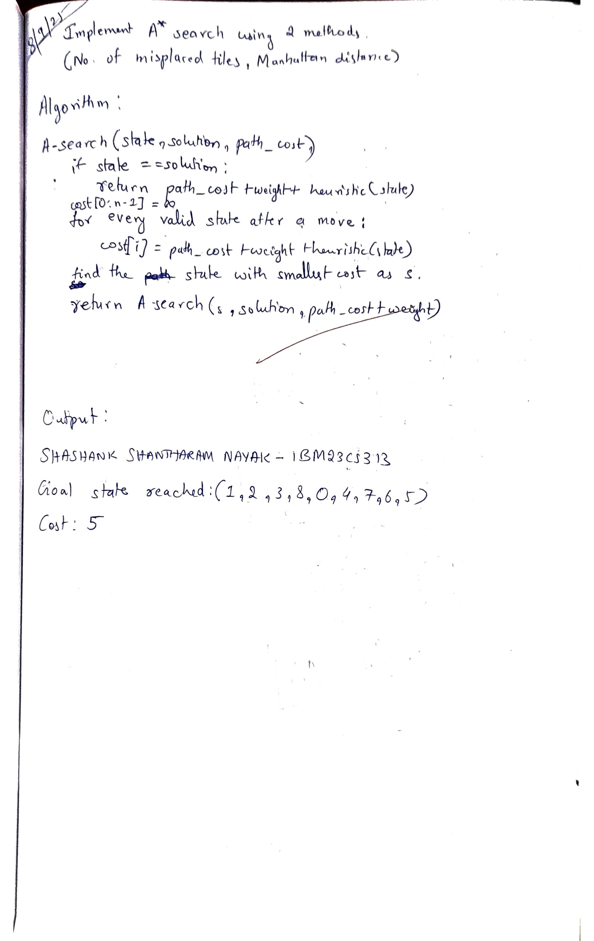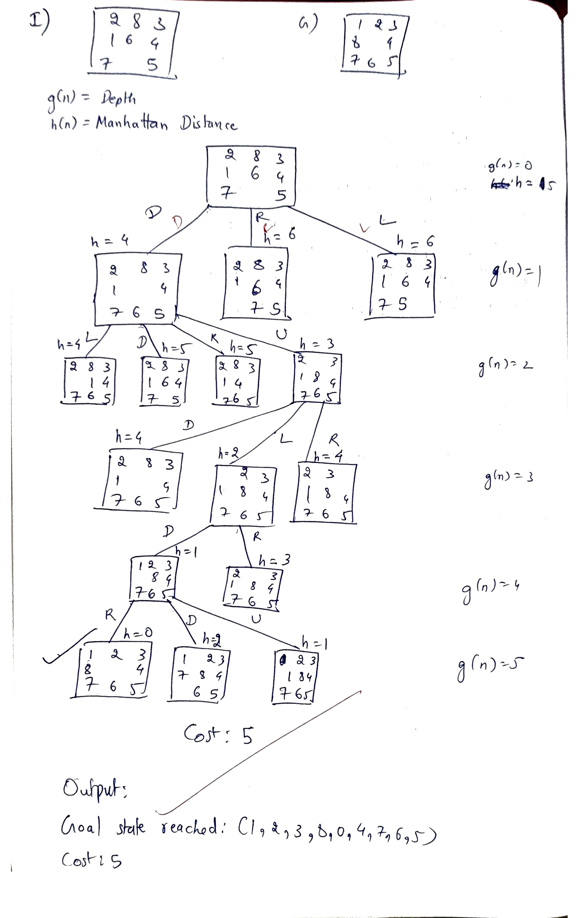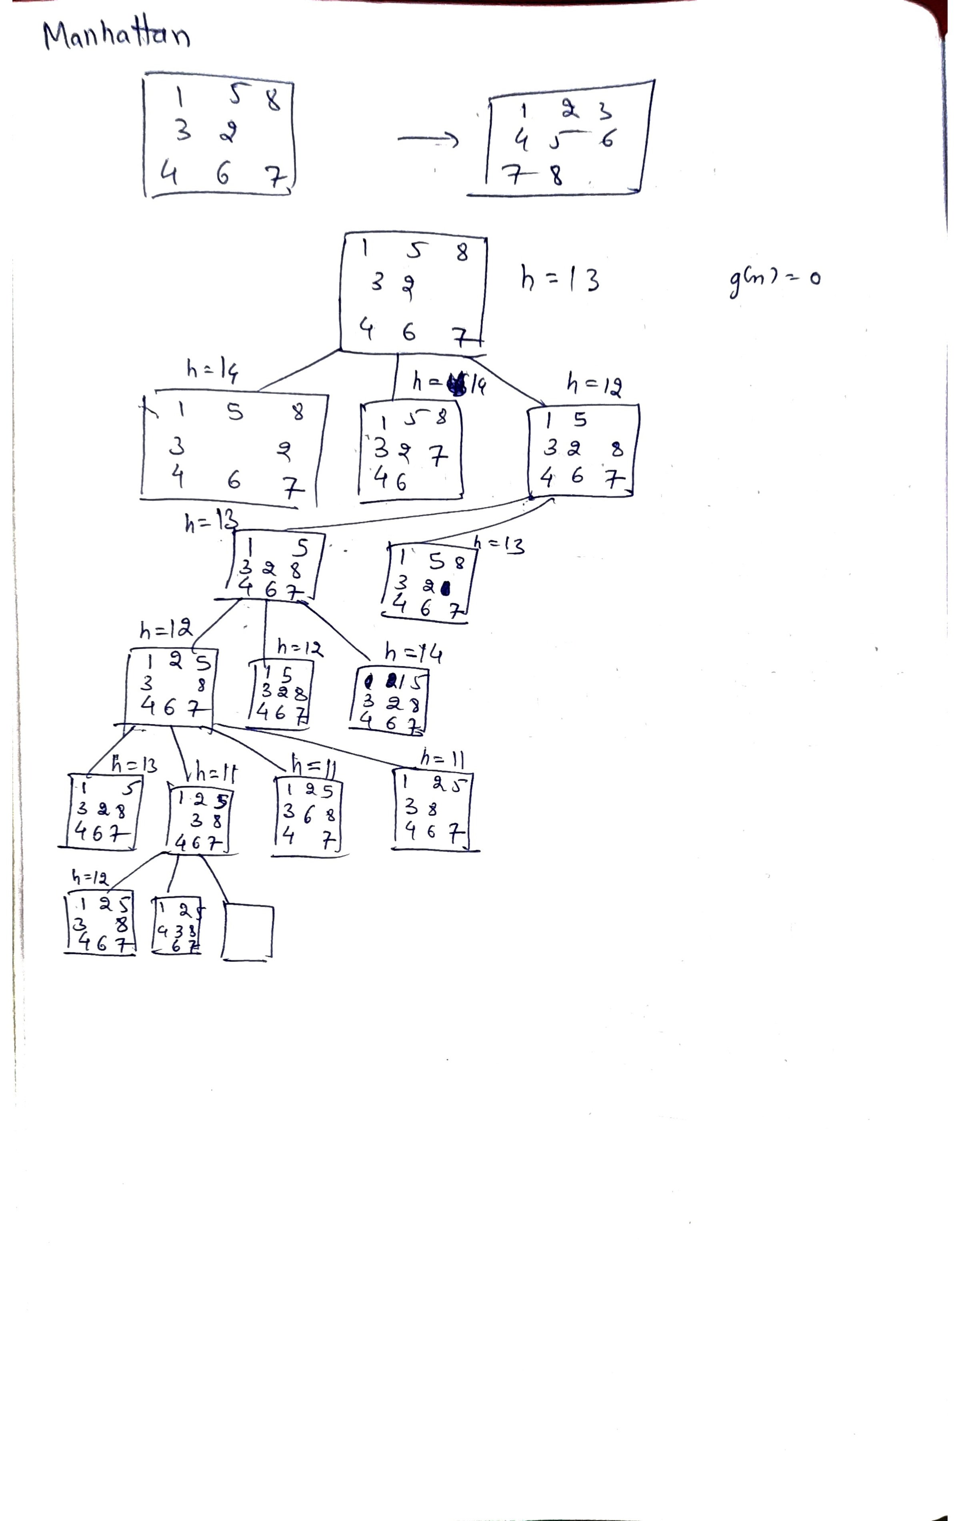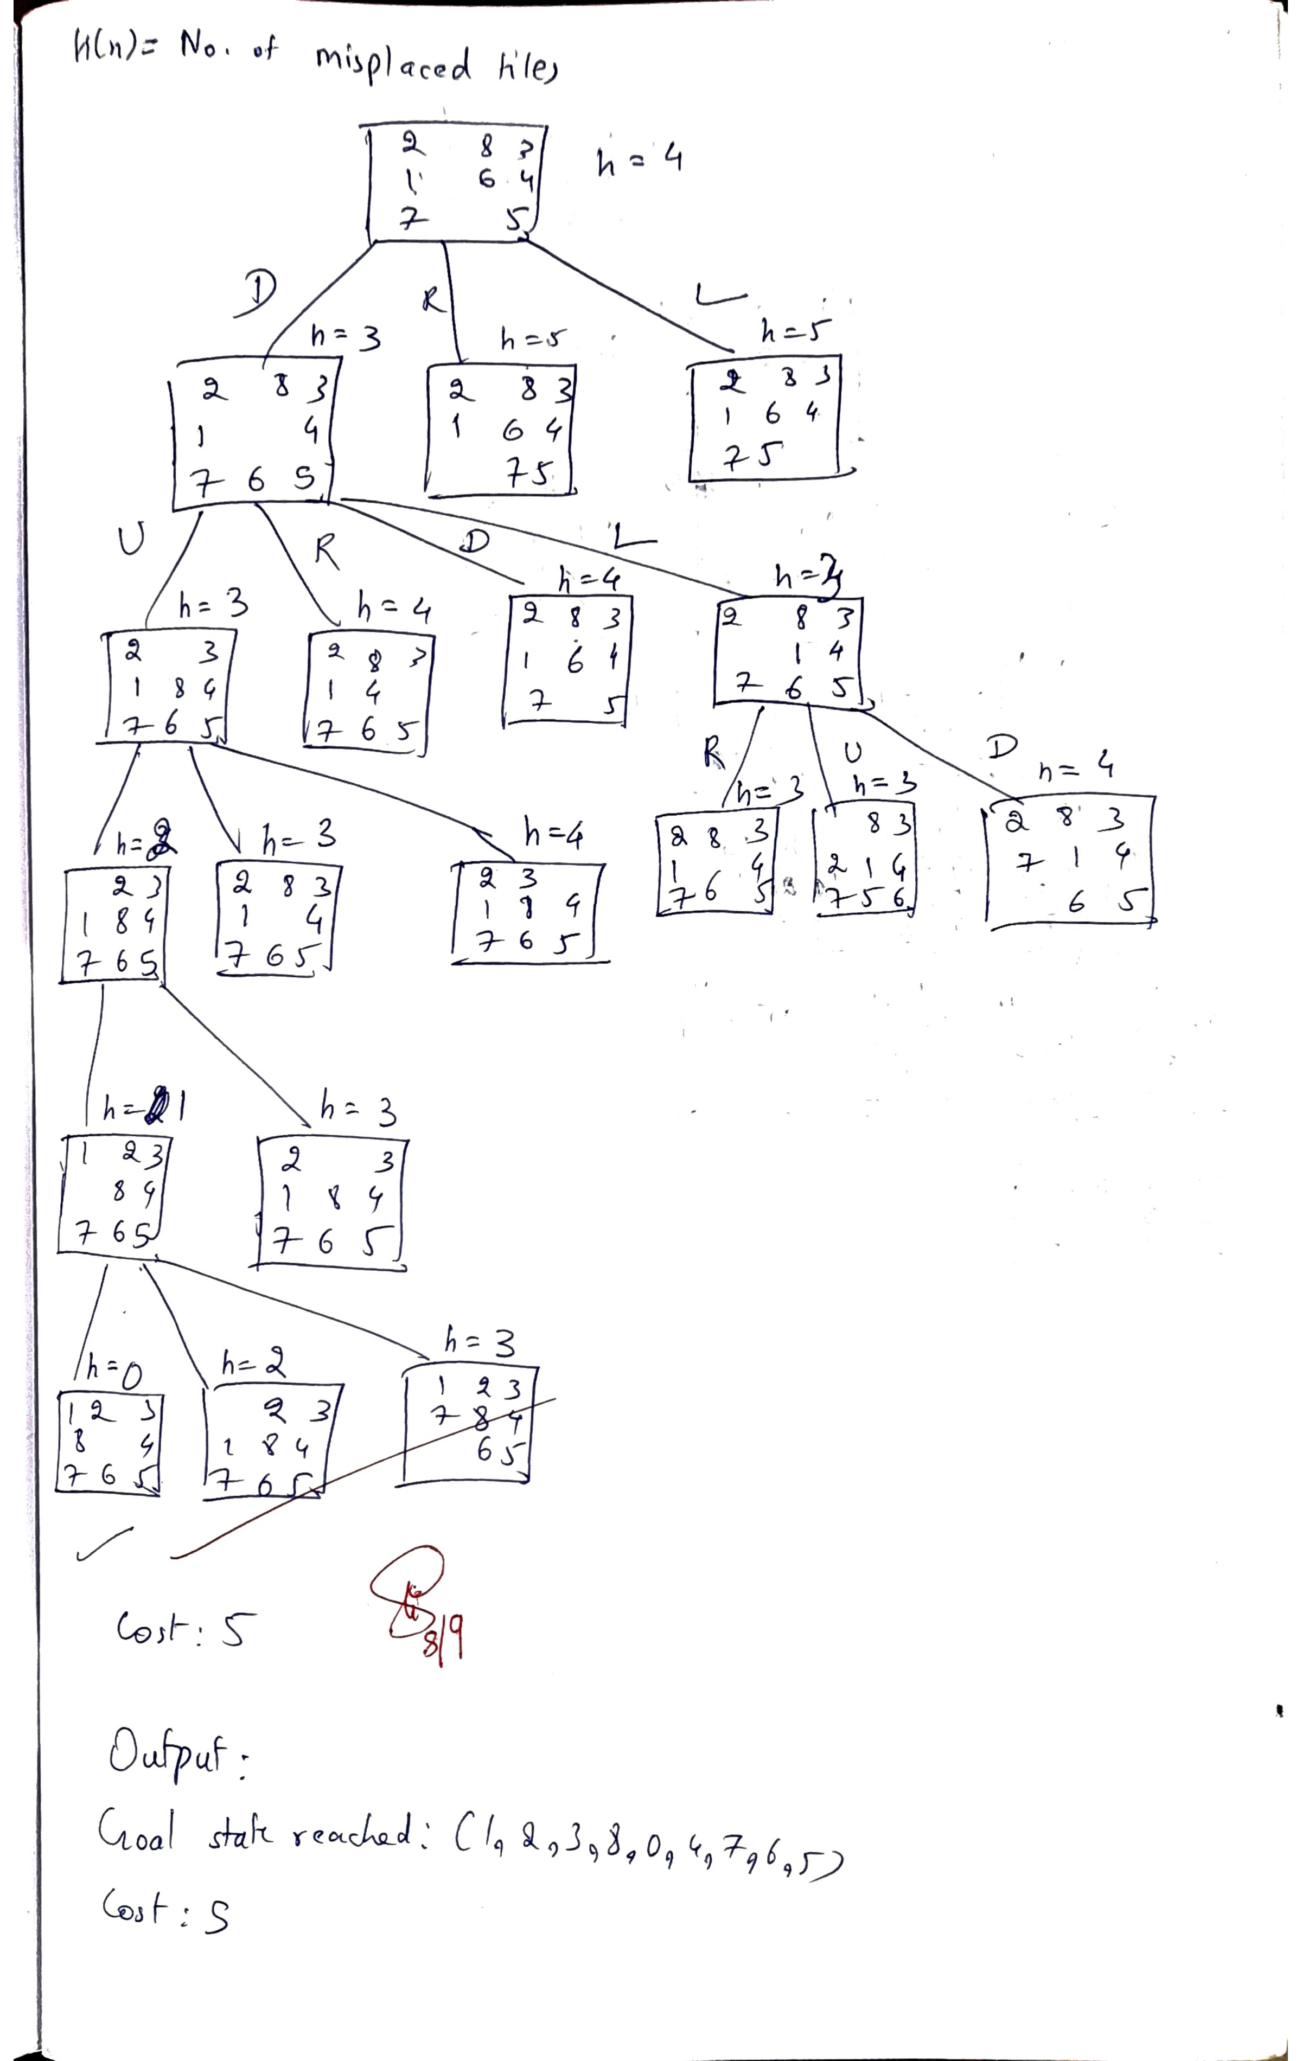

Code:
A* Search
import heapq

# Define the goal state for the 8-puzzle
goal_state = (1, 2, 3, 8, 0, 4, 7, 6, 5) # The solved puzzle

# Manhattan Distance Heuristic

def manhattan_distance(state):
distance = 0
for i in range(9):
if state[i] != 0: # Ignore the empty space
goal_pos = goal_state.index(state[i])
current_row, current_col = divmod(i, 3)
goal_row, goal_col = divmod(goal_pos, 3)
distance += abs(current_row - goal_row) + \
abs(current_col - goal_col)
return distance

# Generate possible moves (valid states from the current state)

def get_neighbors(state):
neighbors = []
empty_pos = state.index(0) # Find the position of the empty space
row, col = divmod(empty_pos, 3)

# Define the possible moves (up, down, left, right)
directions = [(-1, 0), (1, 0), (0, -1), (0, 1)]

for dr, dc in directions:
new_row, new_col = row + dr, col + dc
if 0 <= new_row < 3 and 0 <= new_col < 3: # Check if within bounds
new_pos = new_row * 3 + new_col
new_state = list(state)
# Swap the empty space with the tile in the new position
new_state[empty_pos], new_state[new_pos] = new_state[new_pos], new_state[empty_pos]
# Store the new state as a tuple
neighbors.append(tuple(new_state))
return neighbors

# A* Search Algorithm (Simplified)

def a_star_search(start_state):
# Priority queue for A* (stores (f(n), state))
open_list = []
heapq.heappush(open_list, (manhattan_distance(start_state), start_state))

# Set to track visited states (to avoid cycles)
visited = set()
visited.add(start_state)

cost = 0 # Initialize the cost

while open_list:
# Pop the state with the lowest f(n) value
_, current_state = heapq.heappop(open_list)

# If we reach the goal state, return it
if current_state == goal_state:
return current_state, cost

cost += 1 # Increment cost by 1 for each move
# Explore neighbors
for neighbor in get_neighbors(current_state):
if neighbor not in visited:
visited.add(neighbor)
f = manhattan_distance(neighbor) # Use heuristic for f(n)
heapq.heappush(open_list, (f, neighbor))

return None, cost # No solution found

# Example Usage
if __name__ == "__main__":
start_state = (2, 8, 3, 1, 6, 4, 7, 0, 5) # A sample unsolved puzzle
solution, total_cost = a_star_search(start_state)

print("SHASHANK SHANTHARAM NAYAK - 1BM23CS313")
if solution:
print("Goal state reached:", solution)
print("Cost:", total_cost) # Print the total cost (number of moves)
else:
print("No solution found.")
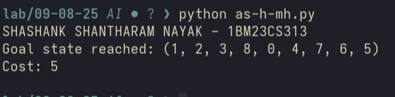
Github Link:
https://github.com/DevelSSN/1BM23CS313-SHASHANK-SHANTHARAM-NAYAK/tree/AI

Program 4
Implement Hill Climbing search algorithm to solve N-Queens problem

Algorithm:
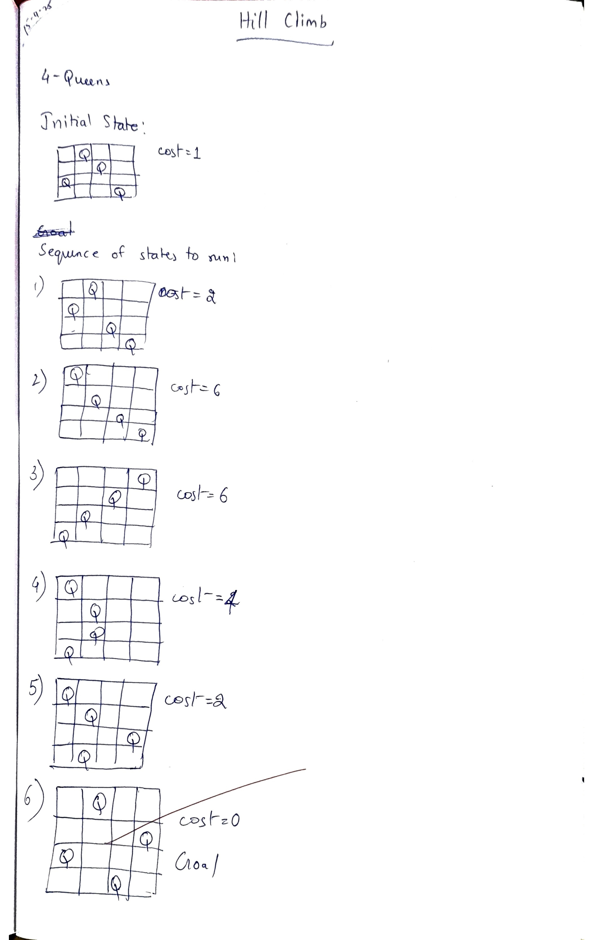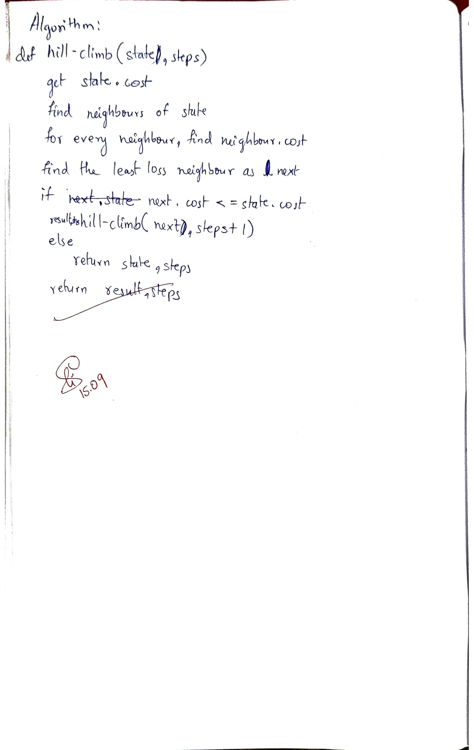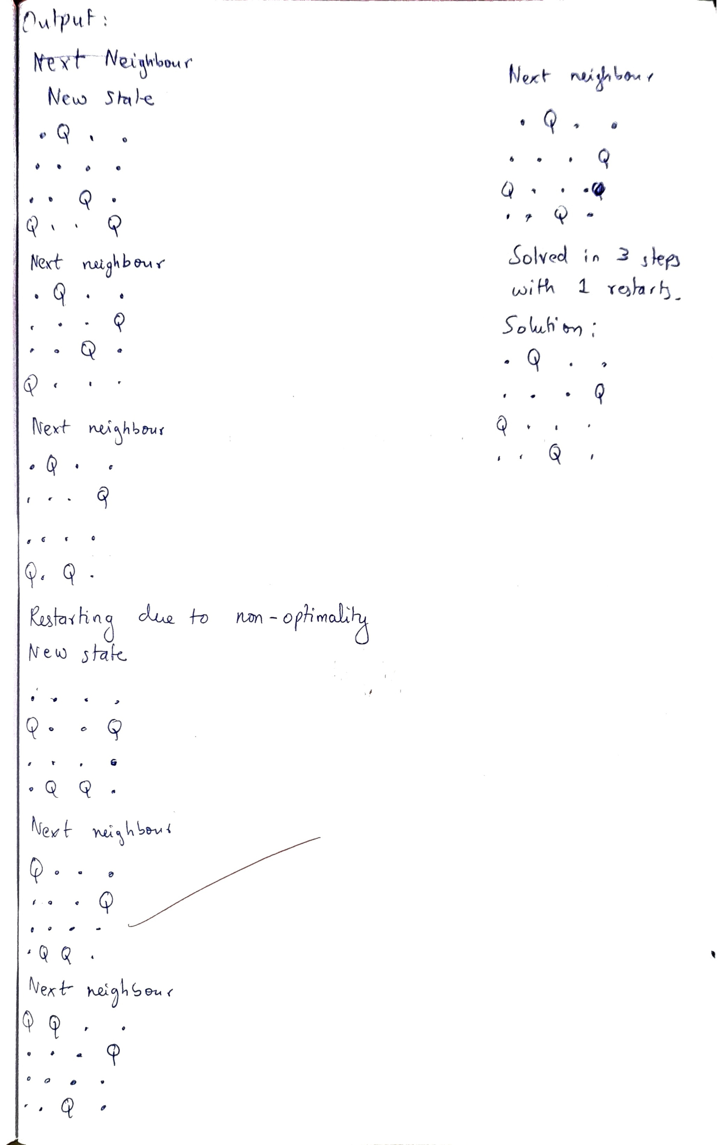

Code:
Hill Climbing
import random

def generate_board(n):
# Randomly place one queen in each column
return [random.randint(0, n - 1) for _ in range(n)]

def compute_conflicts(board):
# Count attacking pairs of queens
conflicts = 0
n = len(board)
for i in range(n):
for j in range(i + 1, n):
if board[i] == board[j] or abs(board[i] - board[j]) == abs(i - j):
conflicts += 1
return conflicts

def get_neighbors(board):
n = len(board)
neighbors = []
for col in range(n):
for row in range(n):
if board[col] != row:
neighbor = list(board)
neighbor[col] = row
neighbors.append(neighbor)
return neighbors

def hill_climbing(n, max_restarts=1000):
for restart in range(max_restarts):
board = generate_board(n)
print("New State")
print_board(board)
steps = 0
while True:
current_conflicts = compute_conflicts(board)
if current_conflicts == 0:
print(f"Solved in {steps} steps with {restart} restarts.")
return board
neighbors = get_neighbors(board)
next_board = min(neighbors, key=compute_conflicts)
print("Next Neighbour")
print_board(next_board)
next_conflicts = compute_conflicts(next_board)
if next_conflicts >= current_conflicts:
print("Restarting due to non-optimality")
break
board = next_board
steps += 1
return None # Failed to find solution

def print_board(board):
n = len(board)
for row in range(n):
line = ""
for col in range(n):
line += "Q " if board[col] == row else ". "
print(line)
print()

# Example usage:
n = 4
solution = hill_climbing(n)
if solution:
print("Solution found:")
print_board(solution)
else:
print("No solution found.")

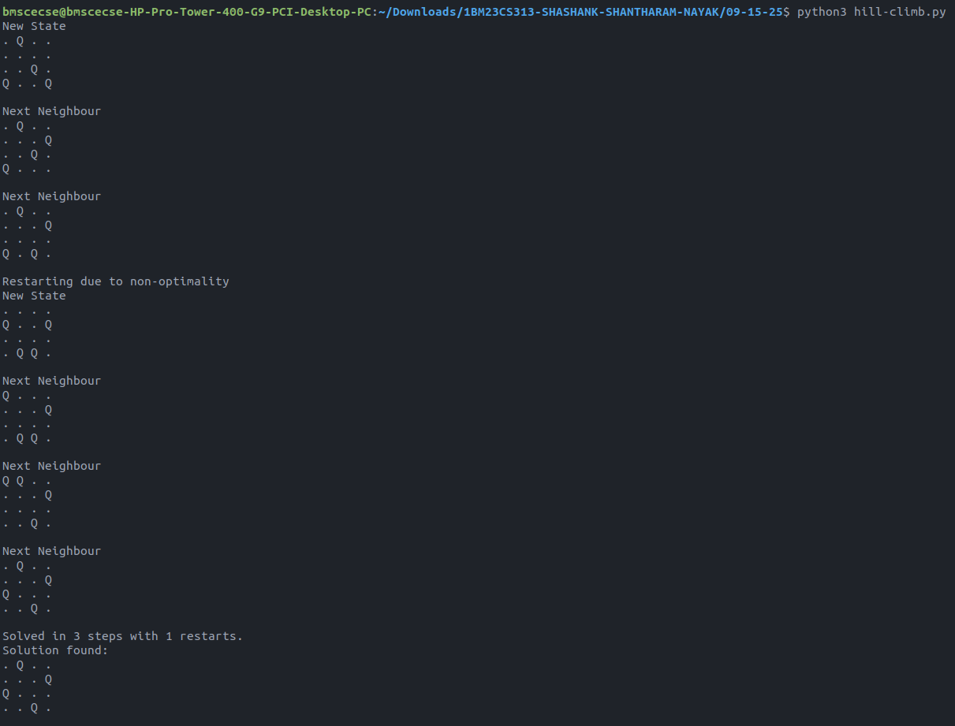
Github Link:
https://github.com/DevelSSN/1BM23CS313-SHASHANK-SHANTHARAM-NAYAK/tree/AI

Program 5
Simulated Annealing to Solve 8-Queens problem

Algorithm:
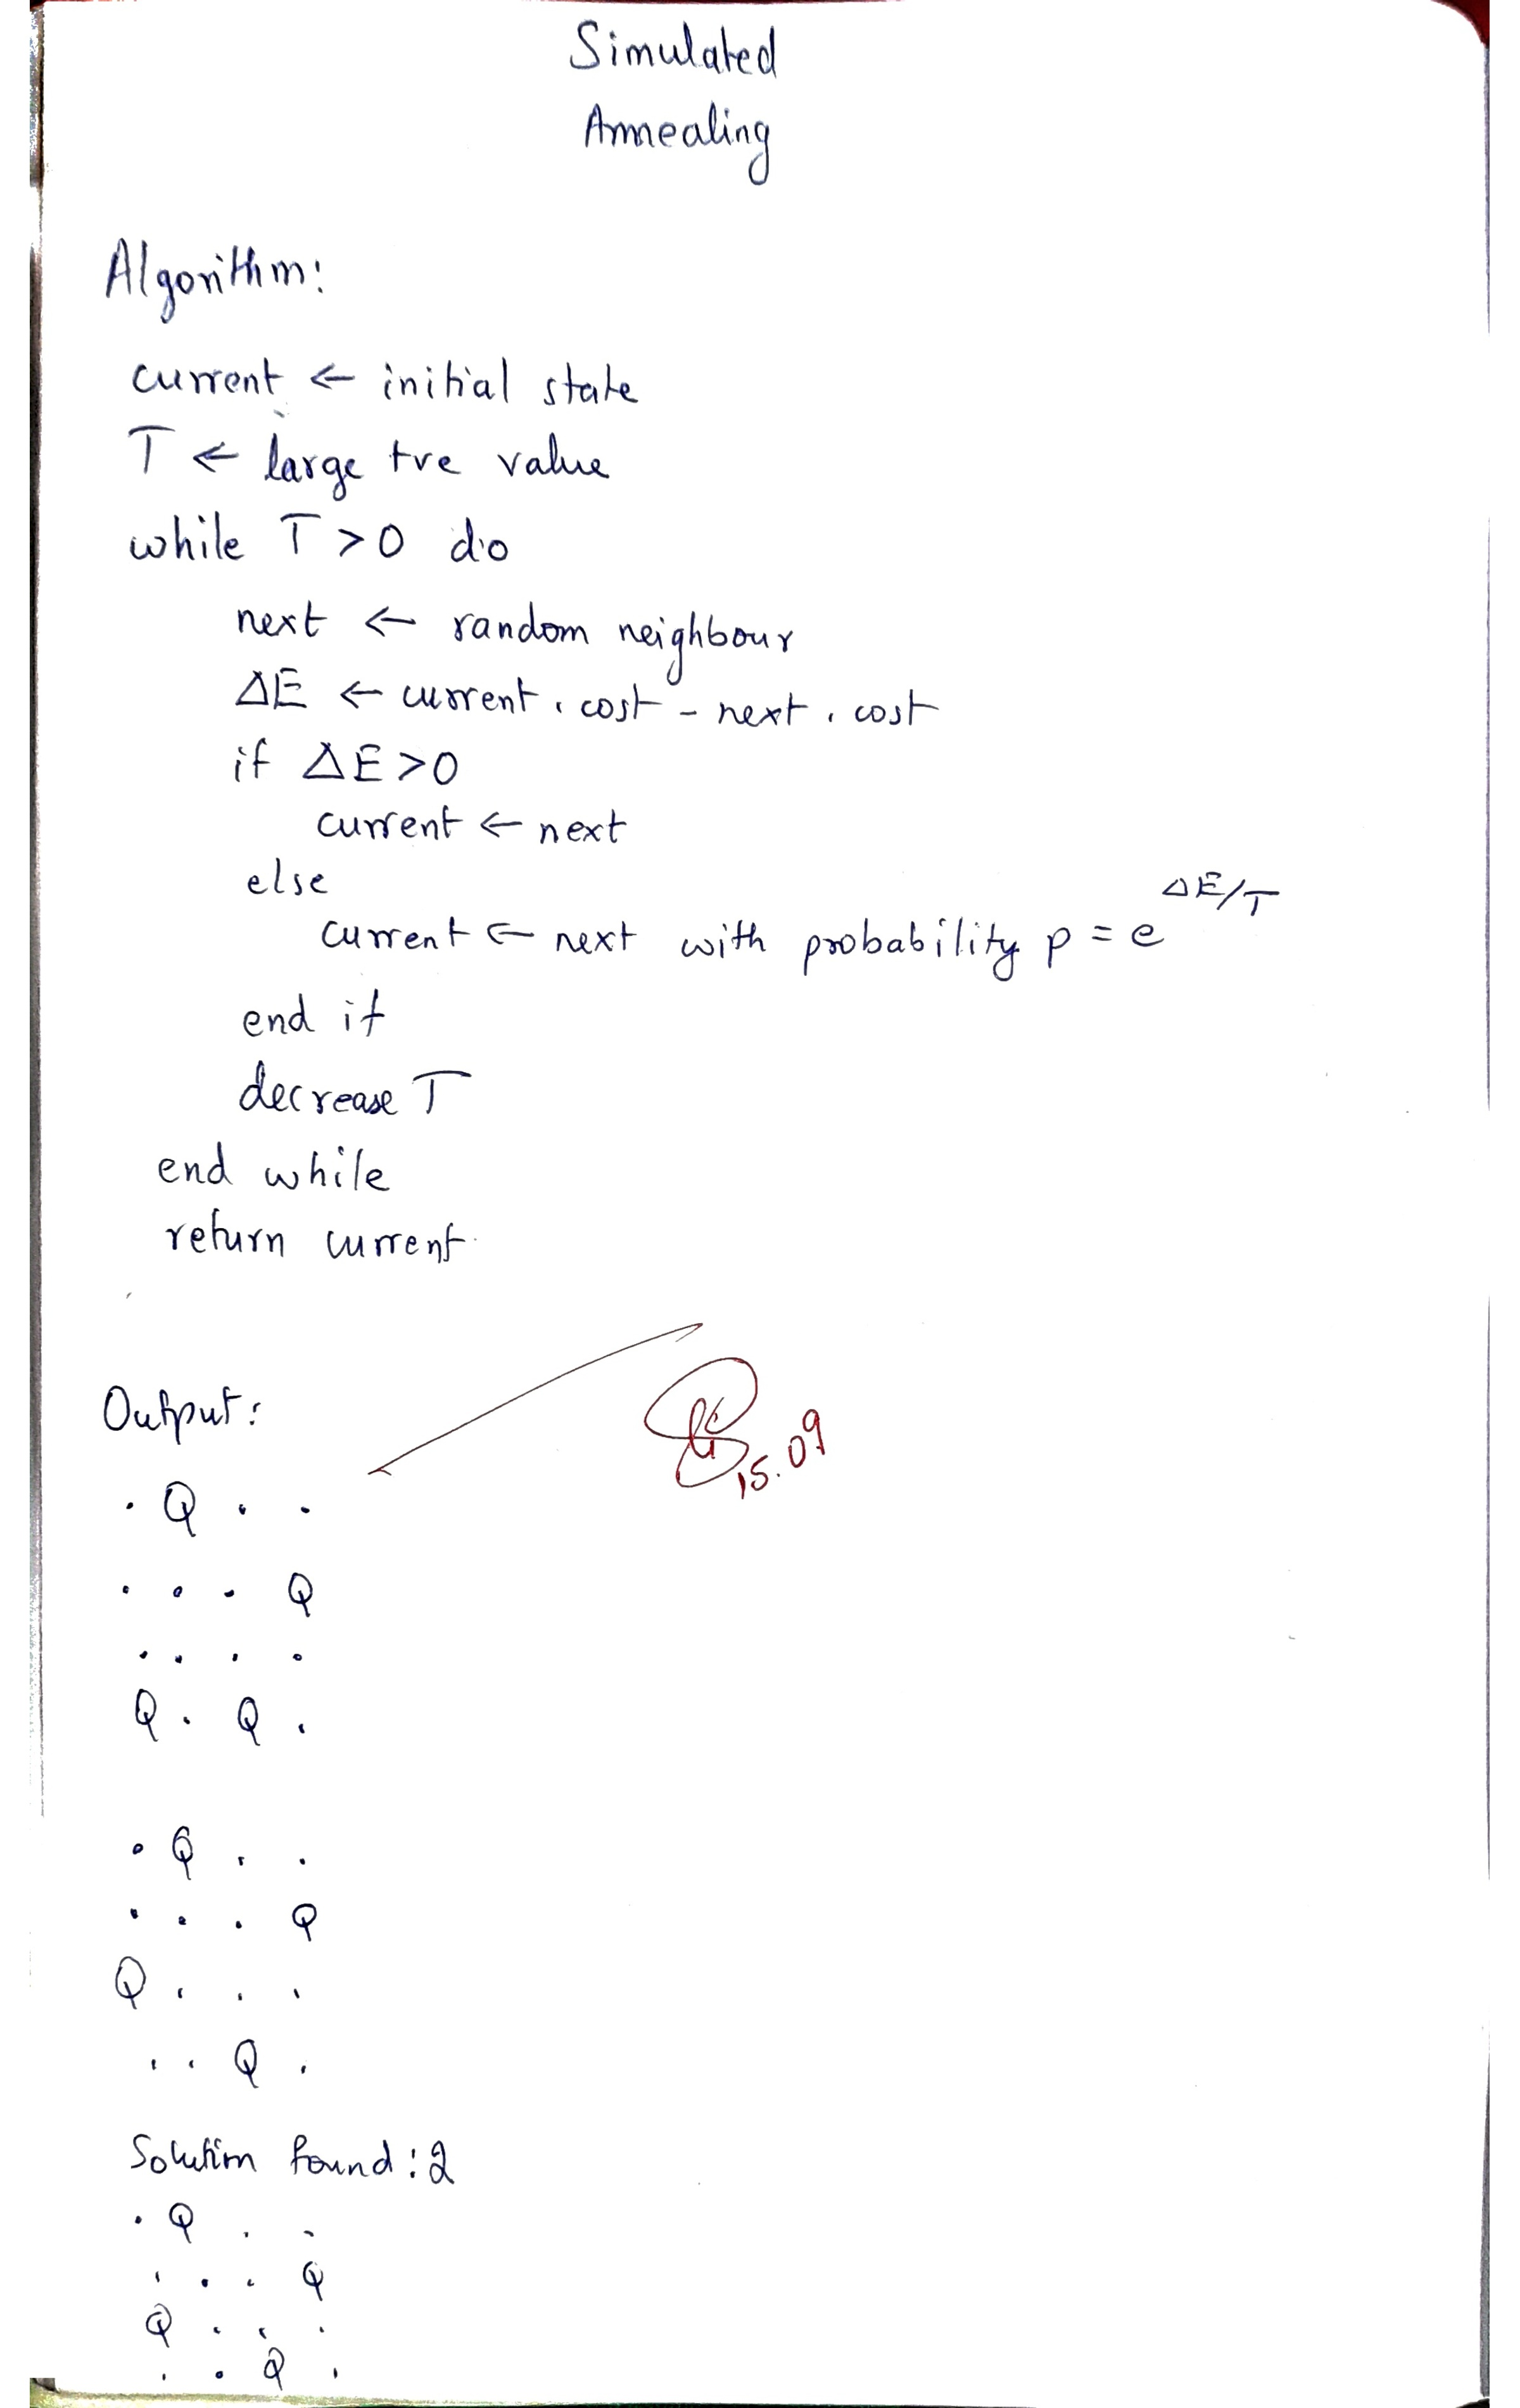

Code:
Simulated Annealing
import random
import math

def generate_board(n):
return [random.randint(0, n - 1) for _ in range(n)]

def compute_conflicts(board):
conflicts = 0
n = len(board)
for i in range(n):
for j in range(i + 1, n):
if board[i] == board[j] or abs(board[i] - board[j]) == abs(i - j):
conflicts += 1
return conflicts

def get_random_neighbor(board):
n = len(board)
dmap = dict()
for col in range(n):
for row in range(n):
if board[col] != row:
neighbor = list(board)
neighbor[col] = row
dmap.setdefault(tuple(neighbor), compute_conflicts(neighbor))
return dmap

def simulated_annealing(n, T=100.0, cool_rate=0.99, min_temp=0.01, max_steps=100000):
current = generate_board(n)
current_cost = compute_conflicts(current)
step = 0
while T > min_temp and step < max_steps:
neighbors = get_random_neighbor(current)
best_neighbor = min(neighbors, key=neighbors.get)
print_board(best_neighbor)
best_cost = neighbors[best_neighbor]

cost_diff = current_cost - best_cost

if cost_diff > 0 or random.random() < math.exp(cost_diff / T):
current = list(best_neighbor)
current_cost = best_cost

T *= cool_rate
step += 1

if current_cost == 0:
return current, step

return None, None

def print_board(board):
n = len(board)
for row in range(n):
print(' '.join('Q' if board[col] == row else '.' for col in range(n)))
print()

n = 4
solution, cost = simulated_annealing(n)

if solution:
print(f"Solution found:{cost}")
print_board(solution)
else:
print("No solution found.")

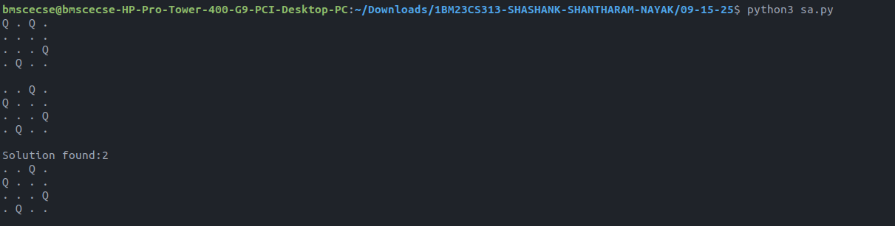
Github Link:
https://github.com/DevelSSN/1BM23CS313-SHASHANK-SHANTHARAM-NAYAK/tree/AI

Program 6
Create a knowledge base using propositional logic and show that the given query entails the knowledge base or not.

Algorithm:
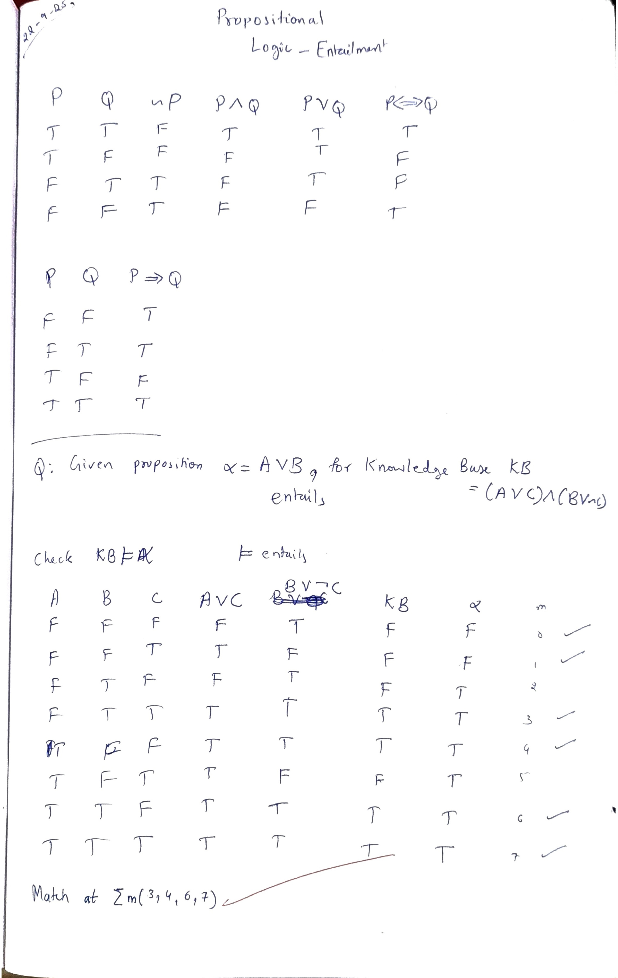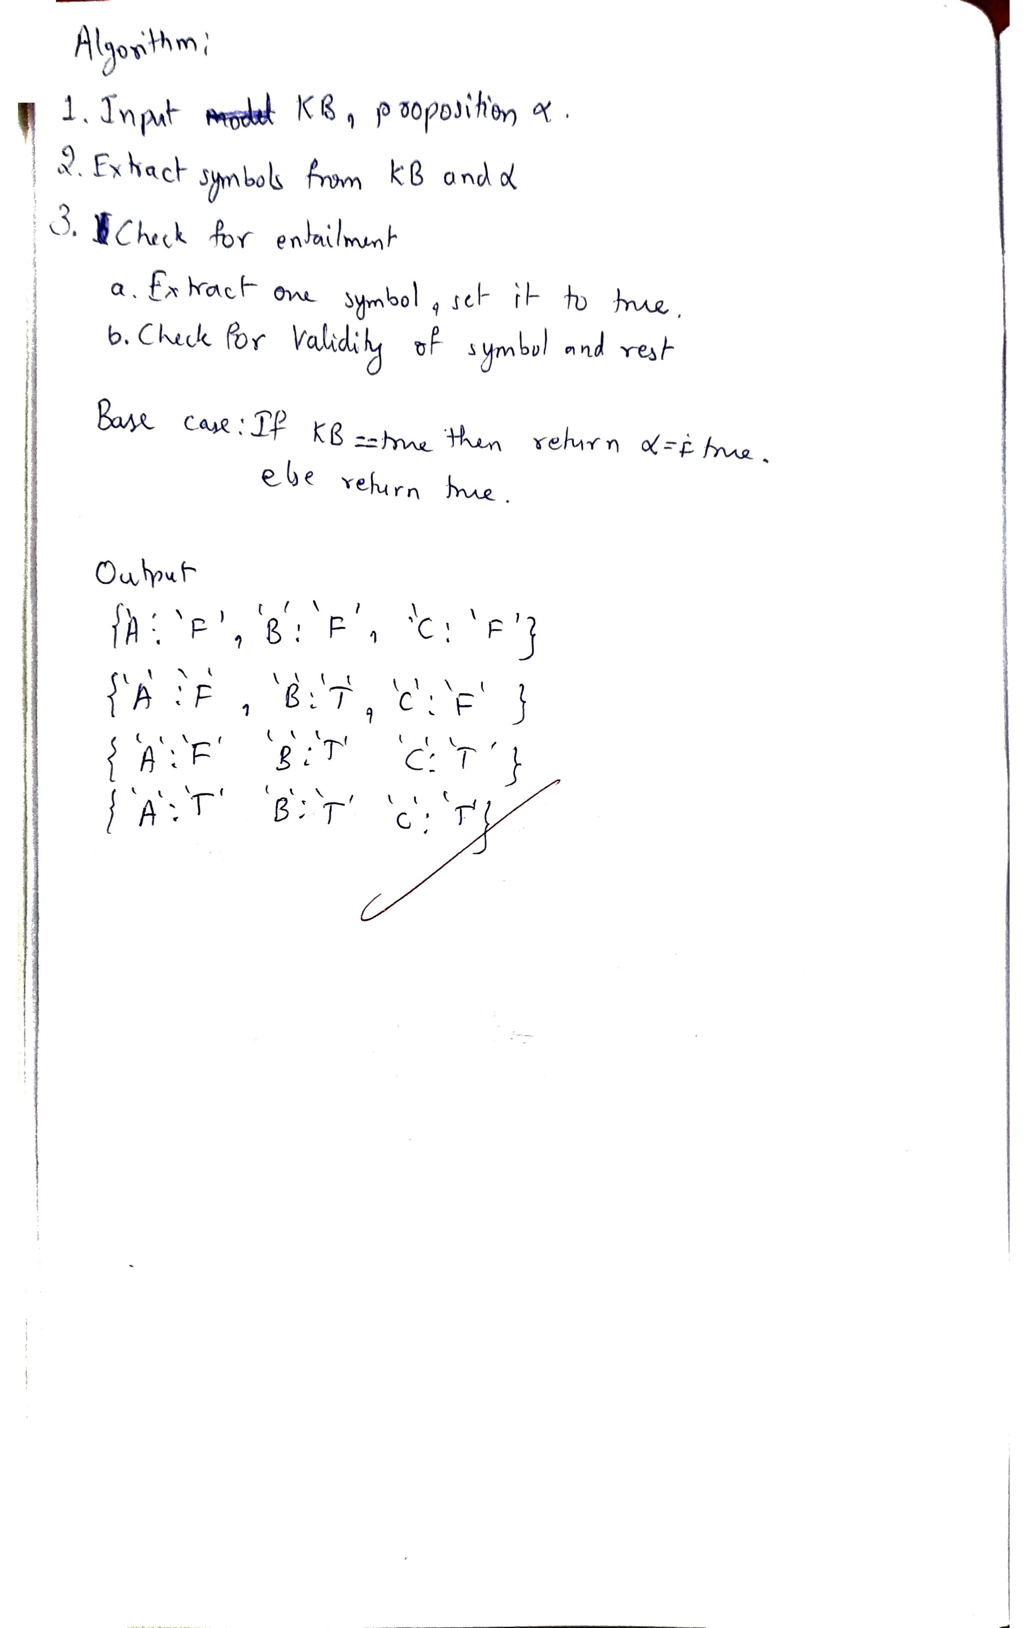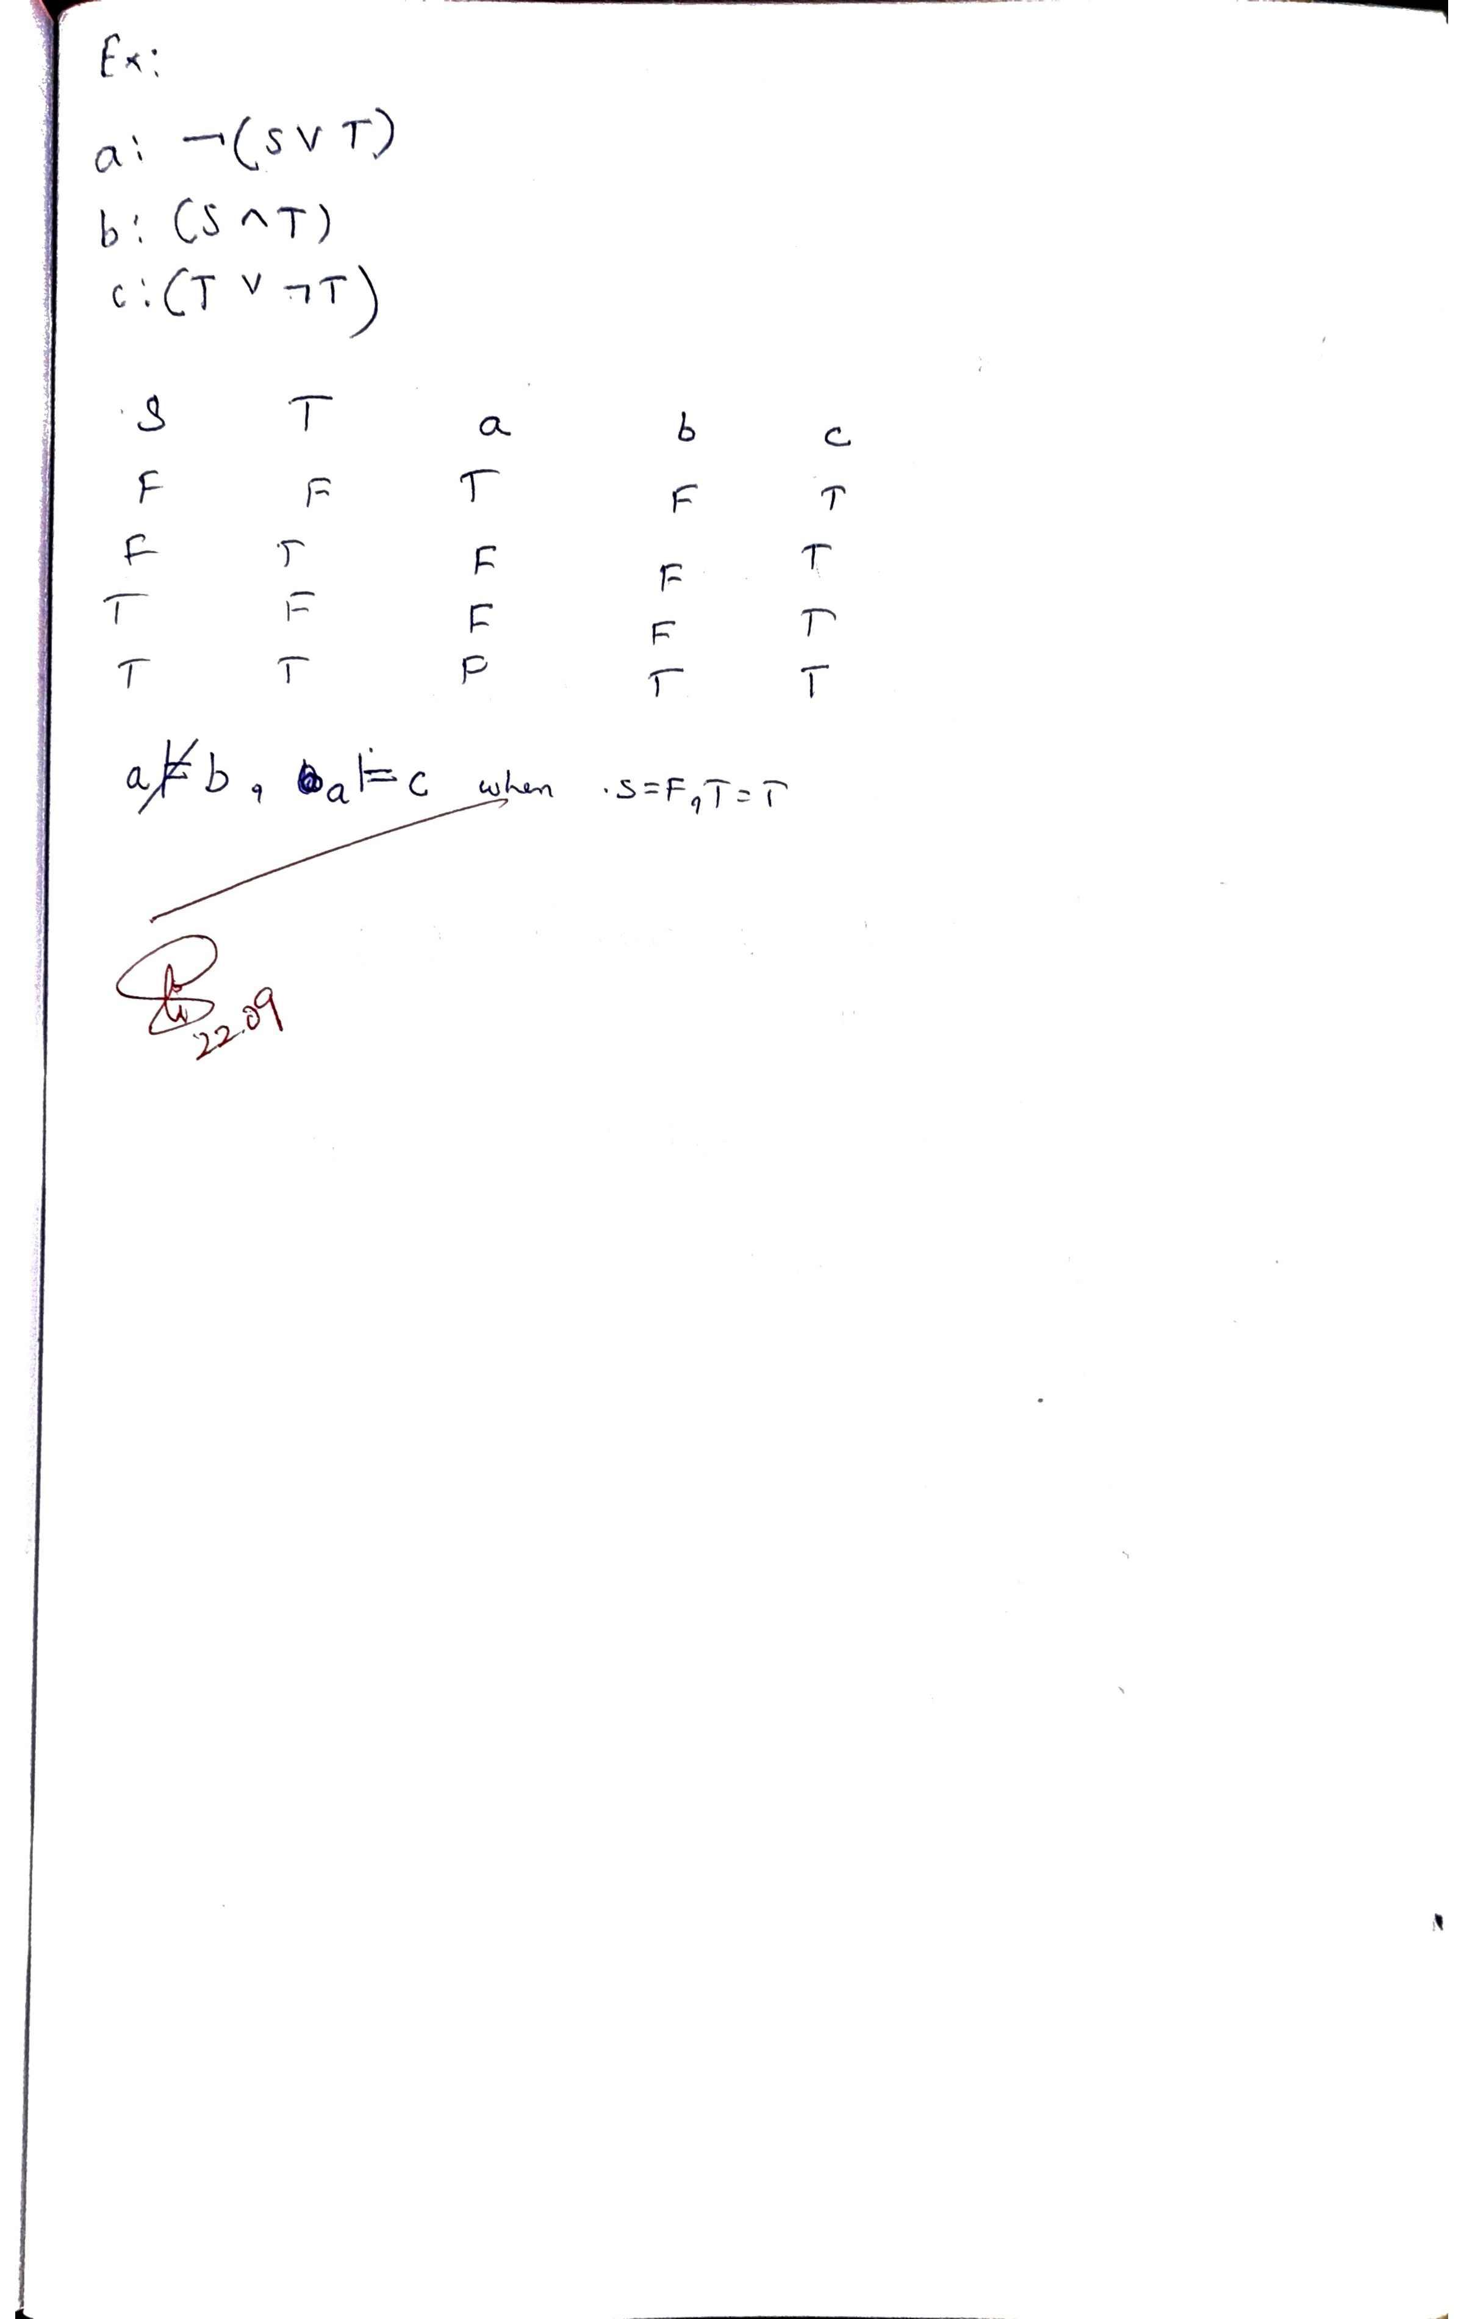

Code:
PL
from itertools import product

def AND(p, q):
return p and q

def OR(p, q):
return p or q

def NOT(p):
return not p

def IMPLIES(p, q):
return (not p) or q

def IFF(p, q):
return p == q

class Formula:
def __init__(self, op, *args):
self.op = op
self.args = args

def evaluate(self, assignment):
if isinstance(self.op, str) and len(self.args) == 0:
return assignment[self.op]

if self.op == 'AND':
return AND(self.args[0].evaluate(assignment), self.args[1].evaluate(assignment))
elif self.op == 'OR':
return OR(self.args[0].evaluate(assignment), self.args[1].evaluate(assignment))
elif self.op == 'NOT':
return NOT(self.args[0].evaluate(assignment))
elif self.op == 'IMPLIES':
return IMPLIES(self.args[0].evaluate(assignment), self.args[1].evaluate(assignment))
elif self.op == 'IFF':
return IFF(self.args[0].evaluate(assignment), self.args[1].evaluate(assignment))
else:
raise ValueError(f"Unknown operator: {self.op}")

def __str__(self):
if isinstance(self.op, str) and len(self.args) == 0:
return self.op
elif self.op == 'NOT':
return f"¬{self.args[0]}"
elif self.op == 'AND':
return f"({self.args[0]} ∧ {self.args[1]})"
elif self.op == 'OR':
return f"({self.args[0]} ∨ {self.args[1]})"
elif self.op == 'IMPLIES':
return f"({self.args[0]} → {self.args[1]})"
elif self.op == 'IFF':
return f"({self.args[0]} ↔ {self.args[1]})"
else:
return f"UnknownOp({self.op})"

def extract_symbols(formula):
symbols = set()
if isinstance(formula.op, str) and len(formula.args) == 0:
symbols.add(formula.op)
else:
for arg in formula.args:
symbols |= extract_symbols(arg)
return symbols

def extract_subformulas(formula):
subs = set()
subs.add(formula)
for arg in formula.args:
subs.add(arg)
return subs

def entails(KB, alpha):
base_symbols = {'A', 'B', 'C'}
symbols_in_formulas = extract_symbols(KB) | extract_symbols(alpha)
all_symbols = sorted(list(base_symbols | symbols_in_formulas))

subformulas_KB = extract_subformulas(KB)
subformulas_alpha = extract_subformulas(alpha)
all_subformulas = list(subformulas_KB | subformulas_alpha)

all_subformulas = [f for f in all_subformulas if not (
isinstance(f.op, str) and len(f.args) == 0)]

all_subformulas.sort(key=lambda f: str(f))

print("Knowledge Base (KB):", KB)
print("Alpha (Query):", alpha)
print()

headers = all_symbols + [str(f) for f in all_subformulas] + ["KB", "Alpha"]

truth_table = []
true_assignments = []

for values in product([False, True], repeat=len(all_symbols)):
assignment = dict(zip(all_symbols, values))

subformula_values = []
for f in all_subformulas:
val = f.evaluate(assignment)
subformula_values.append(val)

kb_val = KB.evaluate(assignment)
alpha_val = alpha.evaluate(assignment)

truth_table.append((assignment, subformula_values, kb_val, alpha_val))
if kb_val and alpha_val:
true_assignments.append(assignment)

header_str = " | ".join(f"{h:^12}" for h in headers)
print(header_str)
print("-" * len(header_str))

for assignment, sub_vals, kb_val, alpha_val in truth_table:
vals = ['T' if assignment[s] else 'F' for s in all_symbols]
vals += ['T' if v else 'F' for v in sub_vals]
vals += ['T' if kb_val else 'F', 'T' if alpha_val else 'F']

row_str = " | ".join(f"{v:^12}" for v in vals)
print(row_str)

print("\nAssignments where both KB and Alpha are TRUE:")
if true_assignments:
for a in true_assignments:
print({k: ('T' if v else 'F') for k, v in a.items()})
else:
print("None")

for assignment, sub_vals, kb_val, alpha_val in truth_table:
if kb_val and not alpha_val:
print("\nResult: KB does NOT entail Alpha.")
return False

print("\nResult: KB entails Alpha.")
return True

A = Formula('A')
B = Formula('B')
C = Formula('C')

KB = Formula('IFF',
Formula('IMPLIES',
Formula('AND', A, Formula('NOT', B)),
Formula('OR', C, A)),
Formula('OR', B, Formula('NOT', C))
)

alpha = Formula('IMPLIES', A, C)

result = entails(KB, alpha)
print(f"\nDoes KB entail alpha? {result}")

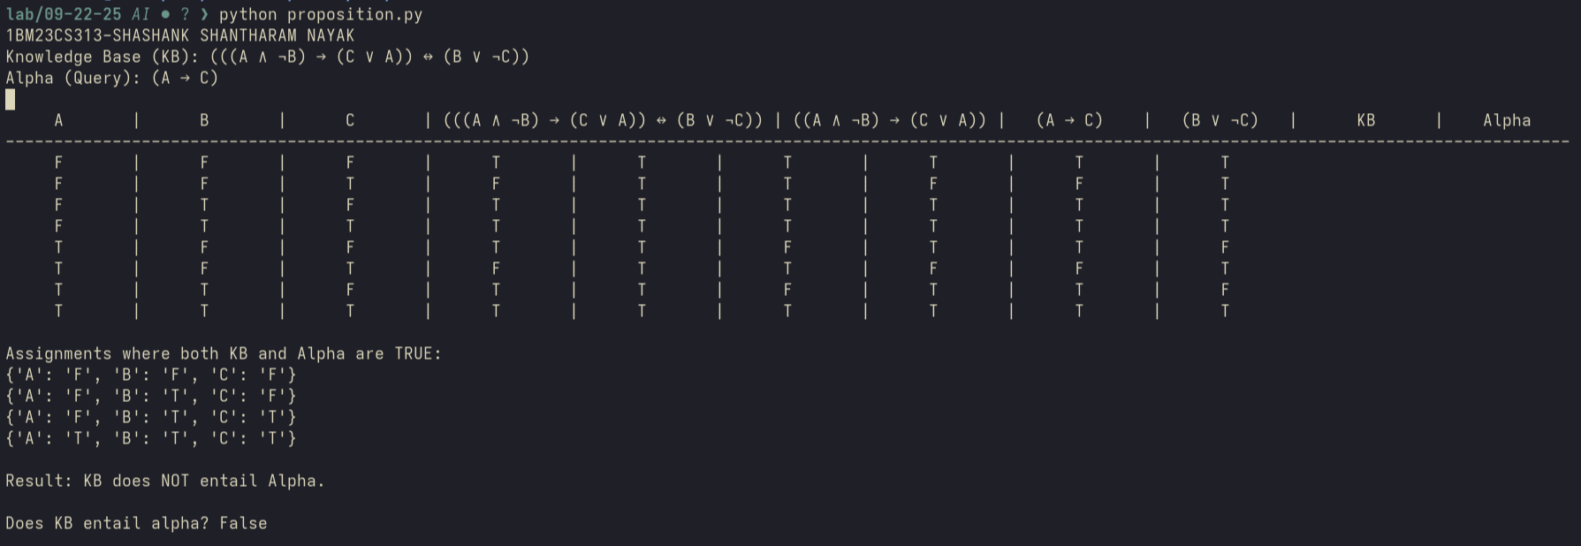
Github Link:
https://github.com/DevelSSN/1BM23CS313-SHASHANK-SHANTHARAM-NAYAK/tree/AI

Program 7
Implement unification in first order logic

Algorithm:
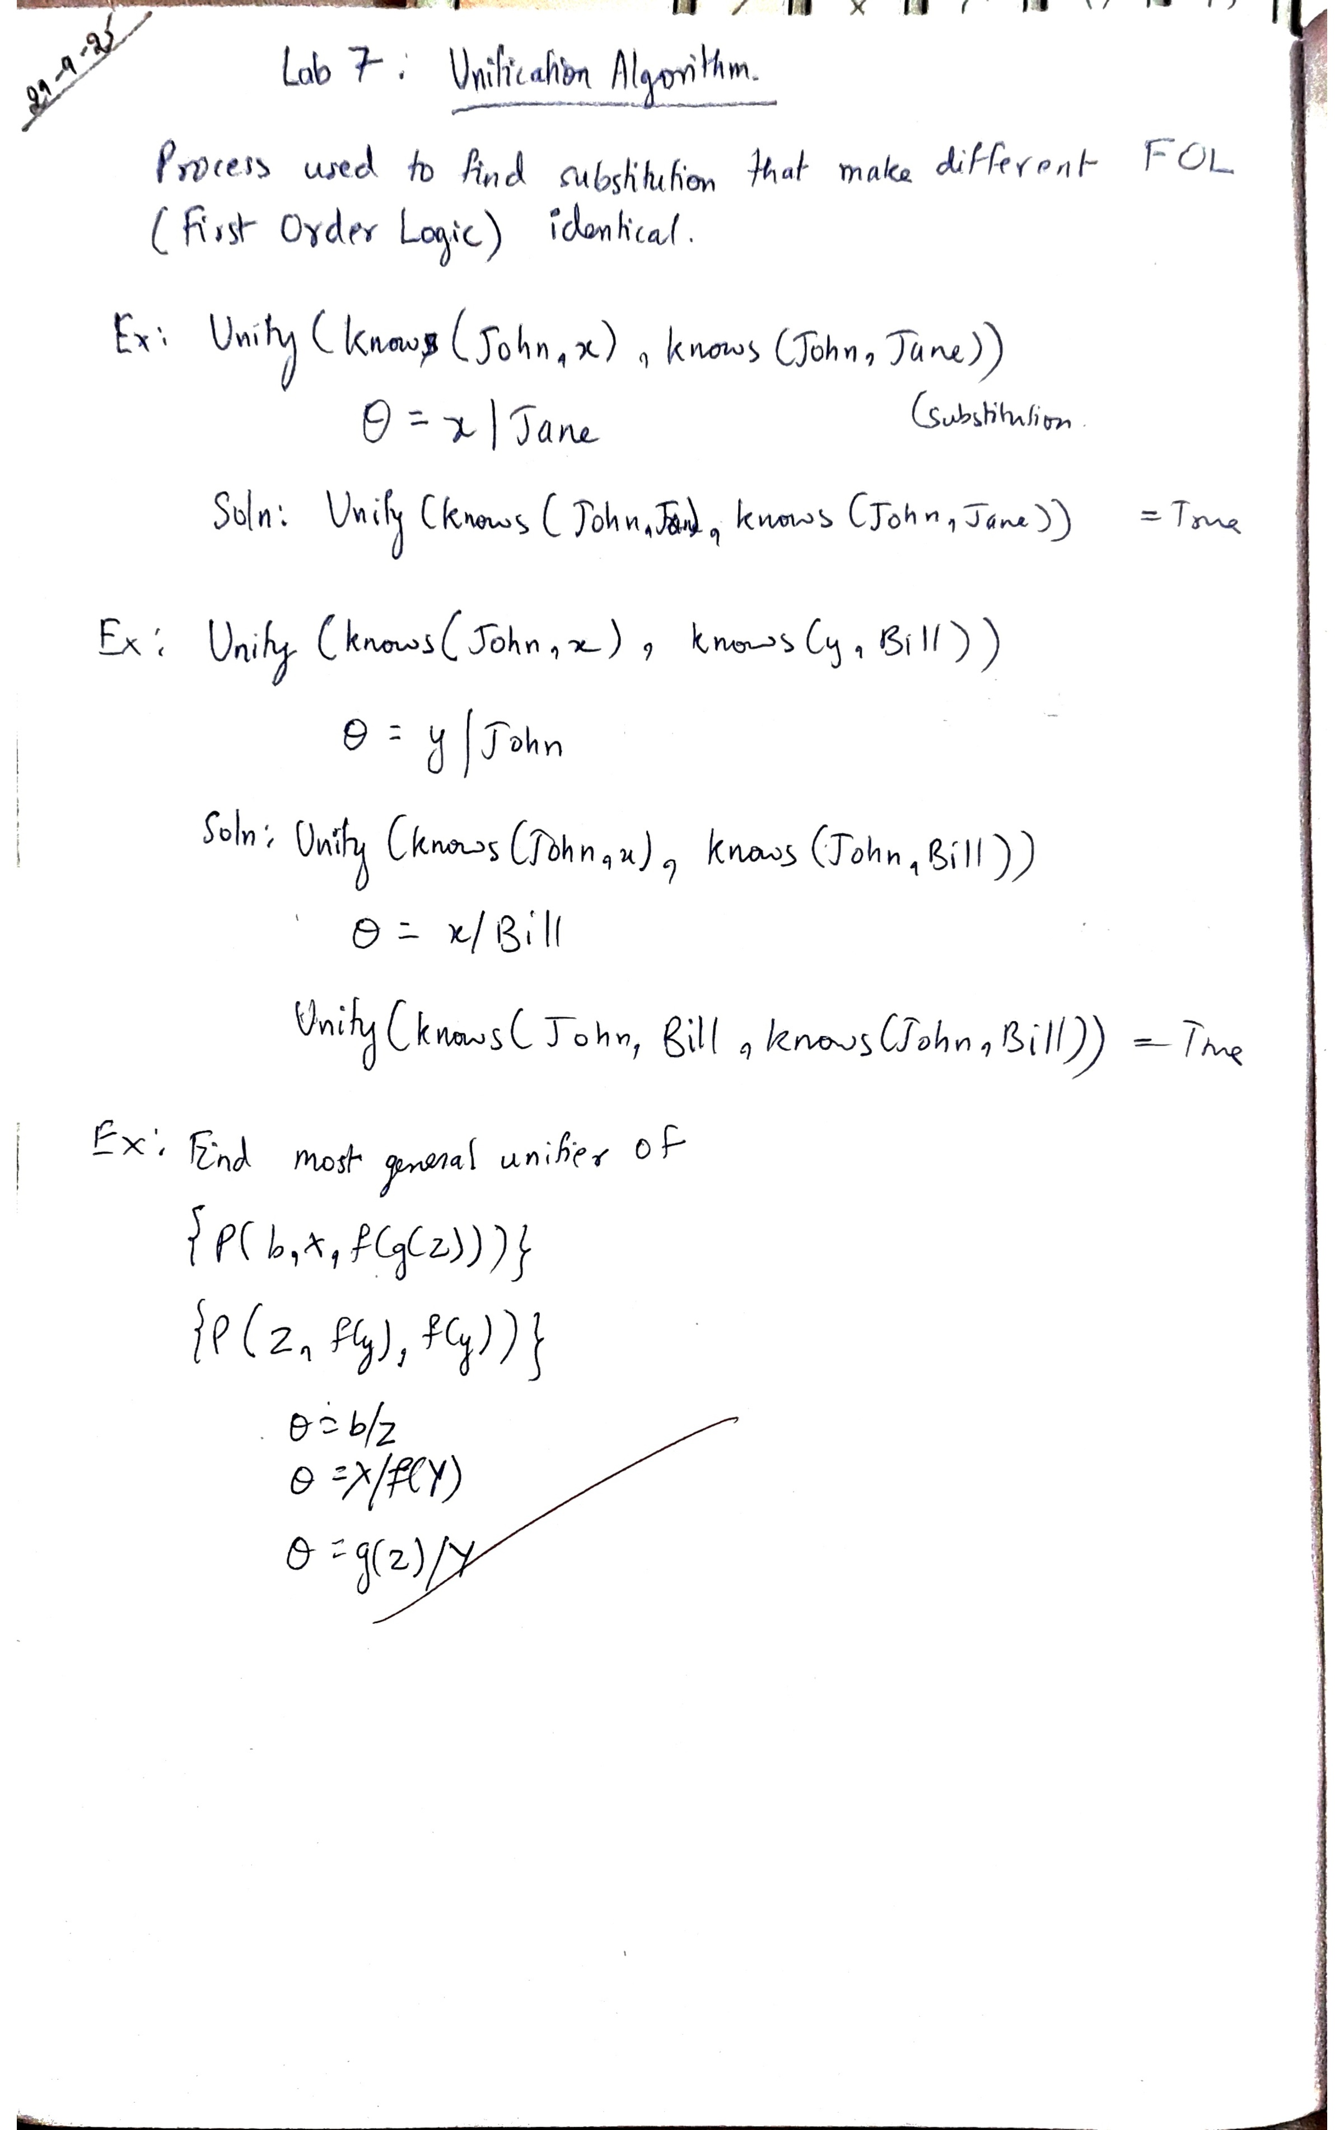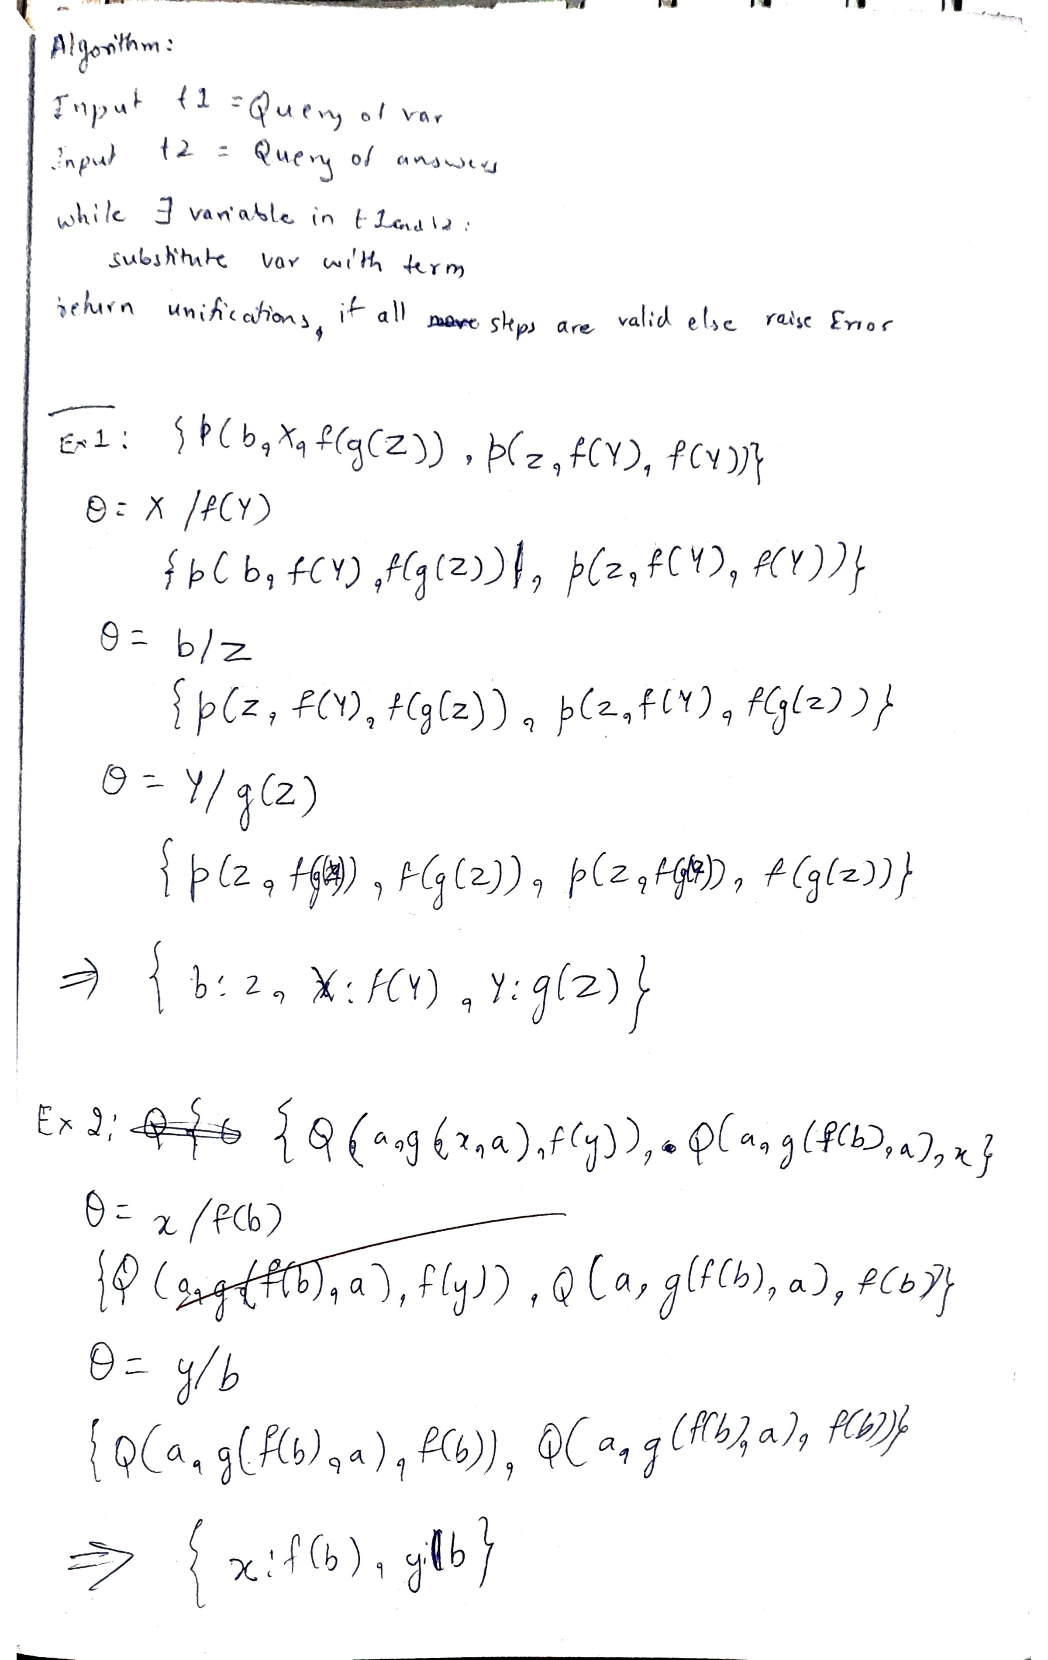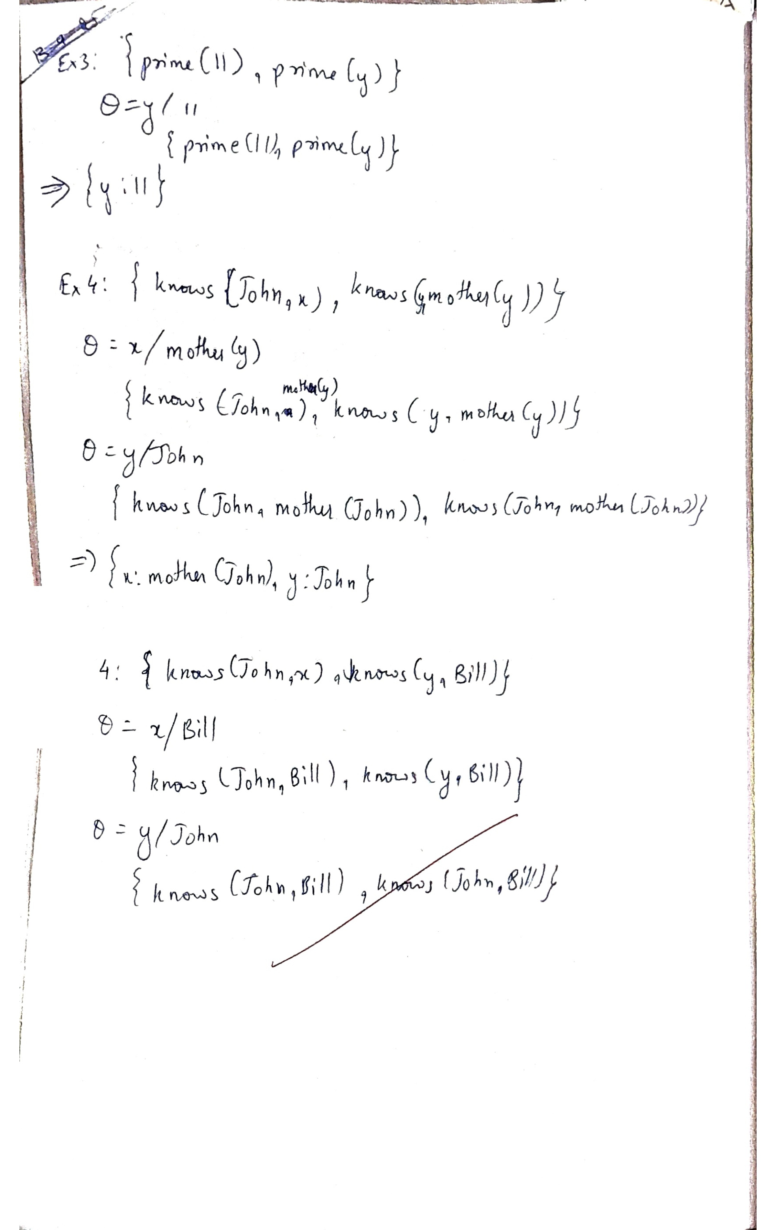

Code:
Unification
def is_variable(term):
return isinstance(term, str) and term[0].islower()

def occurs_check(var, term, subst):
if var == term:
return True
elif is_variable(term):
if term in subst:
return occurs_check(var, subst[term], subst)
else:
return False
elif isinstance(term, tuple):
return any(occurs_check(var, arg, subst) for arg in term[1])
else:
return False

def substitute(term, subst):
if is_variable(term):
while term in subst:
term = subst[term]
return term
elif isinstance(term, tuple):
return (term[0], [substitute(arg, subst) for arg in term[1]])
else:
return term

def unify(t1, t2, subst=None):
if subst is None:
subst = {}

t1 = substitute(t1, subst)
t2 = substitute(t2, subst)

if t1 == t2:
return subst
elif is_variable(t1):
if occurs_check(t1, t2, subst):
raise Exception(f"Occurs check failed: {t1} in {t2}")
subst[t1] = t2
return subst
elif is_variable(t2):
return unify(t2, t1, subst)
elif isinstance(t1, tuple) and isinstance(t2, tuple):
if t1[0] != t2[0] or len(t1[1]) != len(t2[1]):
raise Exception(f"Function mismatch: {t1} vs {t2}")
for arg1, arg2 in zip(t1[1], t2[1]):
subst = unify(arg1, arg2, subst)
return subst
else:
raise Exception(f"Cannot unify {t1} and {t2}")

# term1 = ('f', ['x', ('g', ['y'])]) # f(x,g(y))
# term2 = ('f', ['A', ('g', ['B'])]) # f(A,g(B))

term1 = ('p',['b','x',('f',[('g',['z'])])])
term2 = ('p',['z',('f',['y']),('f',['y'])])
print("1BM23CS313-SHASHANK SHANTHARAM NAYAK")
try:
result = unify(term1, term2)
print("Unifier:", result)
except Exception as e:
print("Unification failed:", e)

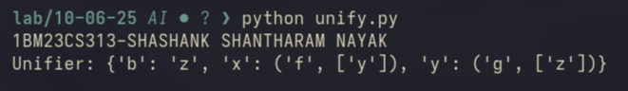
Github Link:
https://github.com/DevelSSN/1BM23CS313-SHASHANK-SHANTHARAM-NAYAK/tree/AI

Program 8
Create a knowledge base consisting of first order logic statements and prove the given query using forward reasoning.

Algorithm:
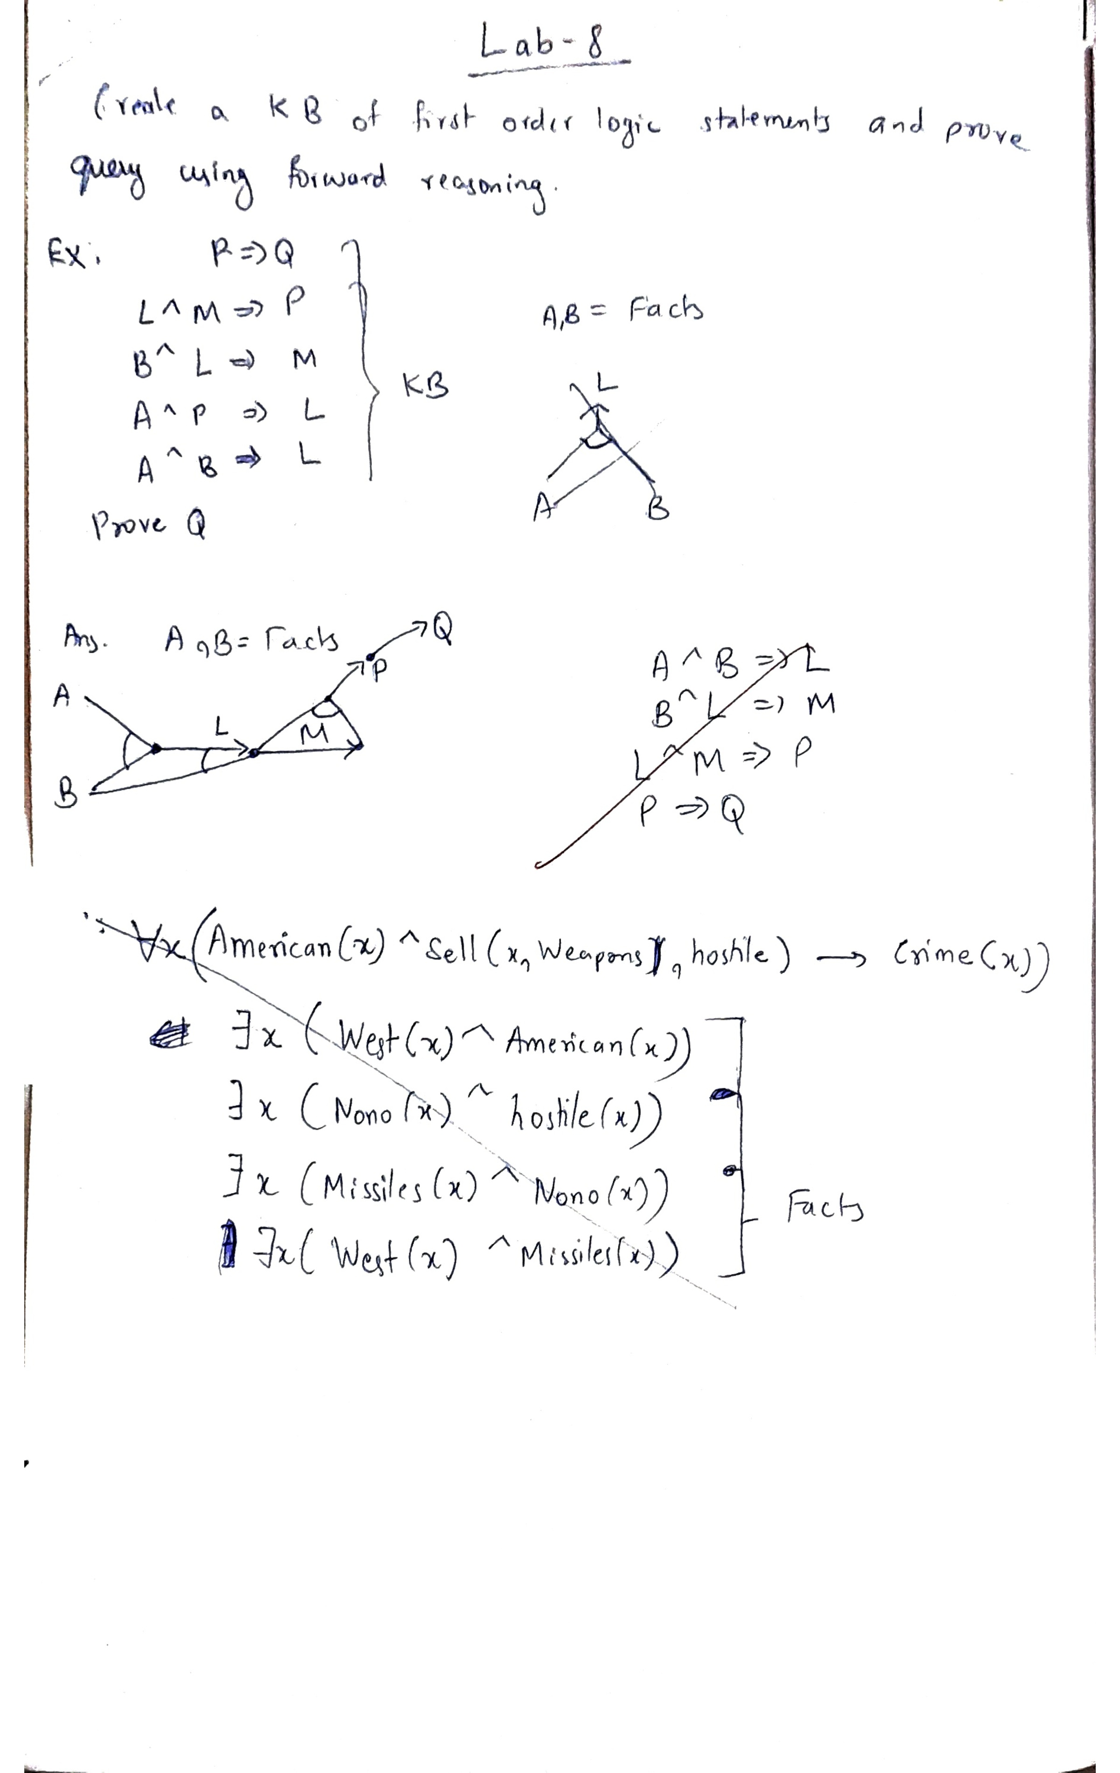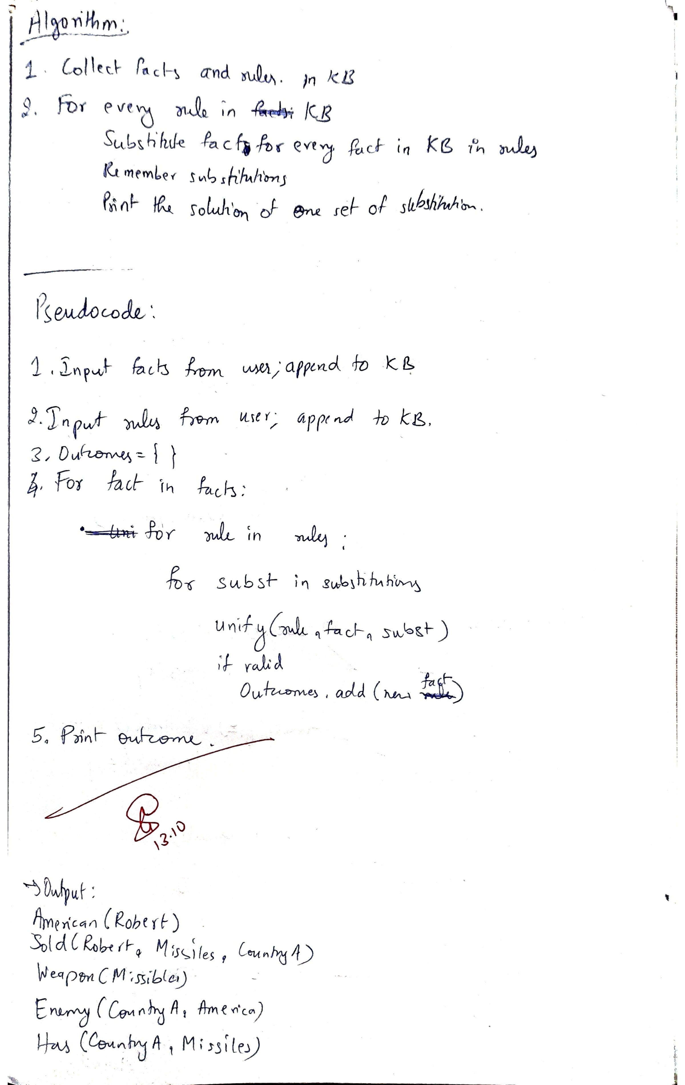
Code:
Forward Reasoning

def is_variable(term):
return isinstance(term, str) and term[0].islower()

def occurs_check(var, term, subst):
if var == term:
return True
elif is_variable(term):
if term in subst:
return occurs_check(var, subst[term], subst)
else:
return False
elif isinstance(term, tuple):
return any(occurs_check(var, arg, subst) for arg in term[1])
else:
return False

def substitute(term, subst):
if is_variable(term):
while term in subst:
term = subst[term]
return term
elif isinstance(term, tuple):
return (term[0], [substitute(arg, subst) for arg in term[1]])
else:
return term

def unify(t1, t2, subst=None):
if subst is None:
subst = {}

t1 = substitute(t1, subst)
t2 = substitute(t2, subst)

if t1 == t2:
return subst
elif is_variable(t1):
if occurs_check(t1, t2, subst):
raise Exception(f"Occurs check failed: {t1} in {t2}")
subst[t1] = t2
return subst
elif is_variable(t2):
return unify(t2, t1, subst)
elif isinstance(t1, tuple) and isinstance(t2, tuple):
if t1[0] != t2[0] or len(t1[1]) != len(t2[1]):
raise Exception(f"Function mismatch: {t1} vs {t2}")
for arg1, arg2 in zip(t1[1], t2[1]):
subst = unify(arg1, arg2, subst)
return subst
else:
raise Exception(f"Cannot unify {t1} and {t2}")

class Fact:
def __init__(self, predicate, arguments):
self.predicate = predicate
self.arguments = arguments

def __eq__(self, other):
if not isinstance(other, Fact):
return False
return self.predicate == other.predicate and self.arguments == other.arguments

def __hash__(self):
return hash((self.predicate, tuple(self.arguments)))

def __str__(self):
return f"{self.predicate}({', '.join(self.arguments)})"

class Rule:
def __init__(self, antecedent, consequent):
self.antecedent = antecedent # A list of Facts
self.consequent = consequent # A single Fact

def __str__(self):
antecedent_str = " & ".join(str(fact) for fact in self.antecedent)
return f"{antecedent_str} => {self.consequent}"

def forward_chaining(knowledge_base):
facts = set(item for item in knowledge_base if isinstance(item, Fact))
new_fact_inferred = True

while new_fact_inferred:
new_fact_inferred = False
for rule in knowledge_base:
if not isinstance(rule, Rule):
continue

# Find substitutions for the antecedent
# This is a simplified approach and might not be fully correct for complex FOL rules
# A more robust implementation would require a more sophisticated matching algorithm
# that considers all combinations of facts and variables.
possible_substitutions = [{}]
antecedent_matched = True

for antecedent_fact in rule.antecedent:
new_possible_substitutions = []
fact_matched_for_antecedent = False
for fact in facts:
for current_subst in possible_substitutions:
try:
# Try to unify the antecedent fact with a known fact
# Create a copy of the substitution for each attempt to avoid side effects
temp_subst = current_subst.copy()
unified_subst = unify(antecedent_fact.predicate, fact.predicate, temp_subst)
if unified_subst is not None:
# Unify arguments
arg_subst = unified_subst.copy()
args_unified = True
if len(antecedent_fact.arguments) == len(fact.arguments):
for arg1, arg2 in zip(antecedent_fact.arguments, fact.arguments):
arg_subst = unify(arg1, arg2, arg_subst)
new_possible_substitutions.append(arg_subst)
fact_matched_for_antecedent = True
else:
args_unified = False
else:
# Predicate mismatch, continue to the next fact
continue

except Exception as e:
# Unification failed, this substitution doesn't work for this fact
pass
if not fact_matched_for_antecedent and not possible_substitutions[0]: # Handles the case where the antecedent has facts but no initial substitution
antecedent_matched = False
break
elif not fact_matched_for_antecedent and possible_substitutions[0]: # Handles the case where no fact matches a part of the antecedent
possible_substitutions = [] # No valid substitution for this rule
antecedent_matched = False
break

possible_substitutions = new_possible_substitutions

if antecedent_matched and possible_substitutions:
# If a consistent substitution is found for all antecedent facts,
# apply it to the consequent
for final_subst in possible_substitutions:
substituted_arguments = [substitute(arg, final_subst) for arg in rule.consequent.arguments]
new_fact = Fact(rule.consequent.predicate, substituted_arguments)

# Check if the new fact is already in the facts set
if new_fact not in facts:
facts.add(new_fact)
new_fact_inferred = True

return facts

knowledge_base = []

knowledge_base.append(Fact("Enemy", ["CountryA", "America"]))

knowledge_base.append(Fact("Has", ["CountryA", "Missiles"]))

knowledge_base.append(Fact("Sold", ["Robert", "Missiles", "CountryA"])) # Representing Robert sold Missiles to CountryA

knowledge_base.append(Fact("American", ["Robert"]))

knowledge_base.append(Fact("Weapon", ["Missiles"]))

rule1_antecedent = [
Fact("American", ["x"]),
Fact("Enemy", ["y", "America"]),
Fact("Sold", ["x", "z", "y"]),
Fact("Weapon", ["z"])
]
rule1_consequent = Fact("Criminal", ["x"])
knowledge_base.append(Rule(rule1_antecedent, rule1_consequent))

print("1BM23CS313-SHASHANK SHANTHARAM NAYAK")
facts = forward_chaining(knowledge_base)
for fact in facts:
print(fact)

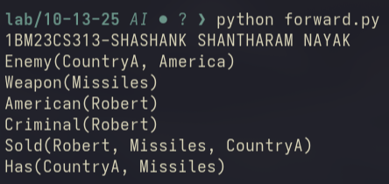
Github Link:
https://github.com/DevelSSN/1BM23CS313-SHASHANK-SHANTHARAM-NAYAK/tree/AI

Program 9
Create a knowledge base consisting of first order logic statements and prove the given query using Resolution

Algorithm:
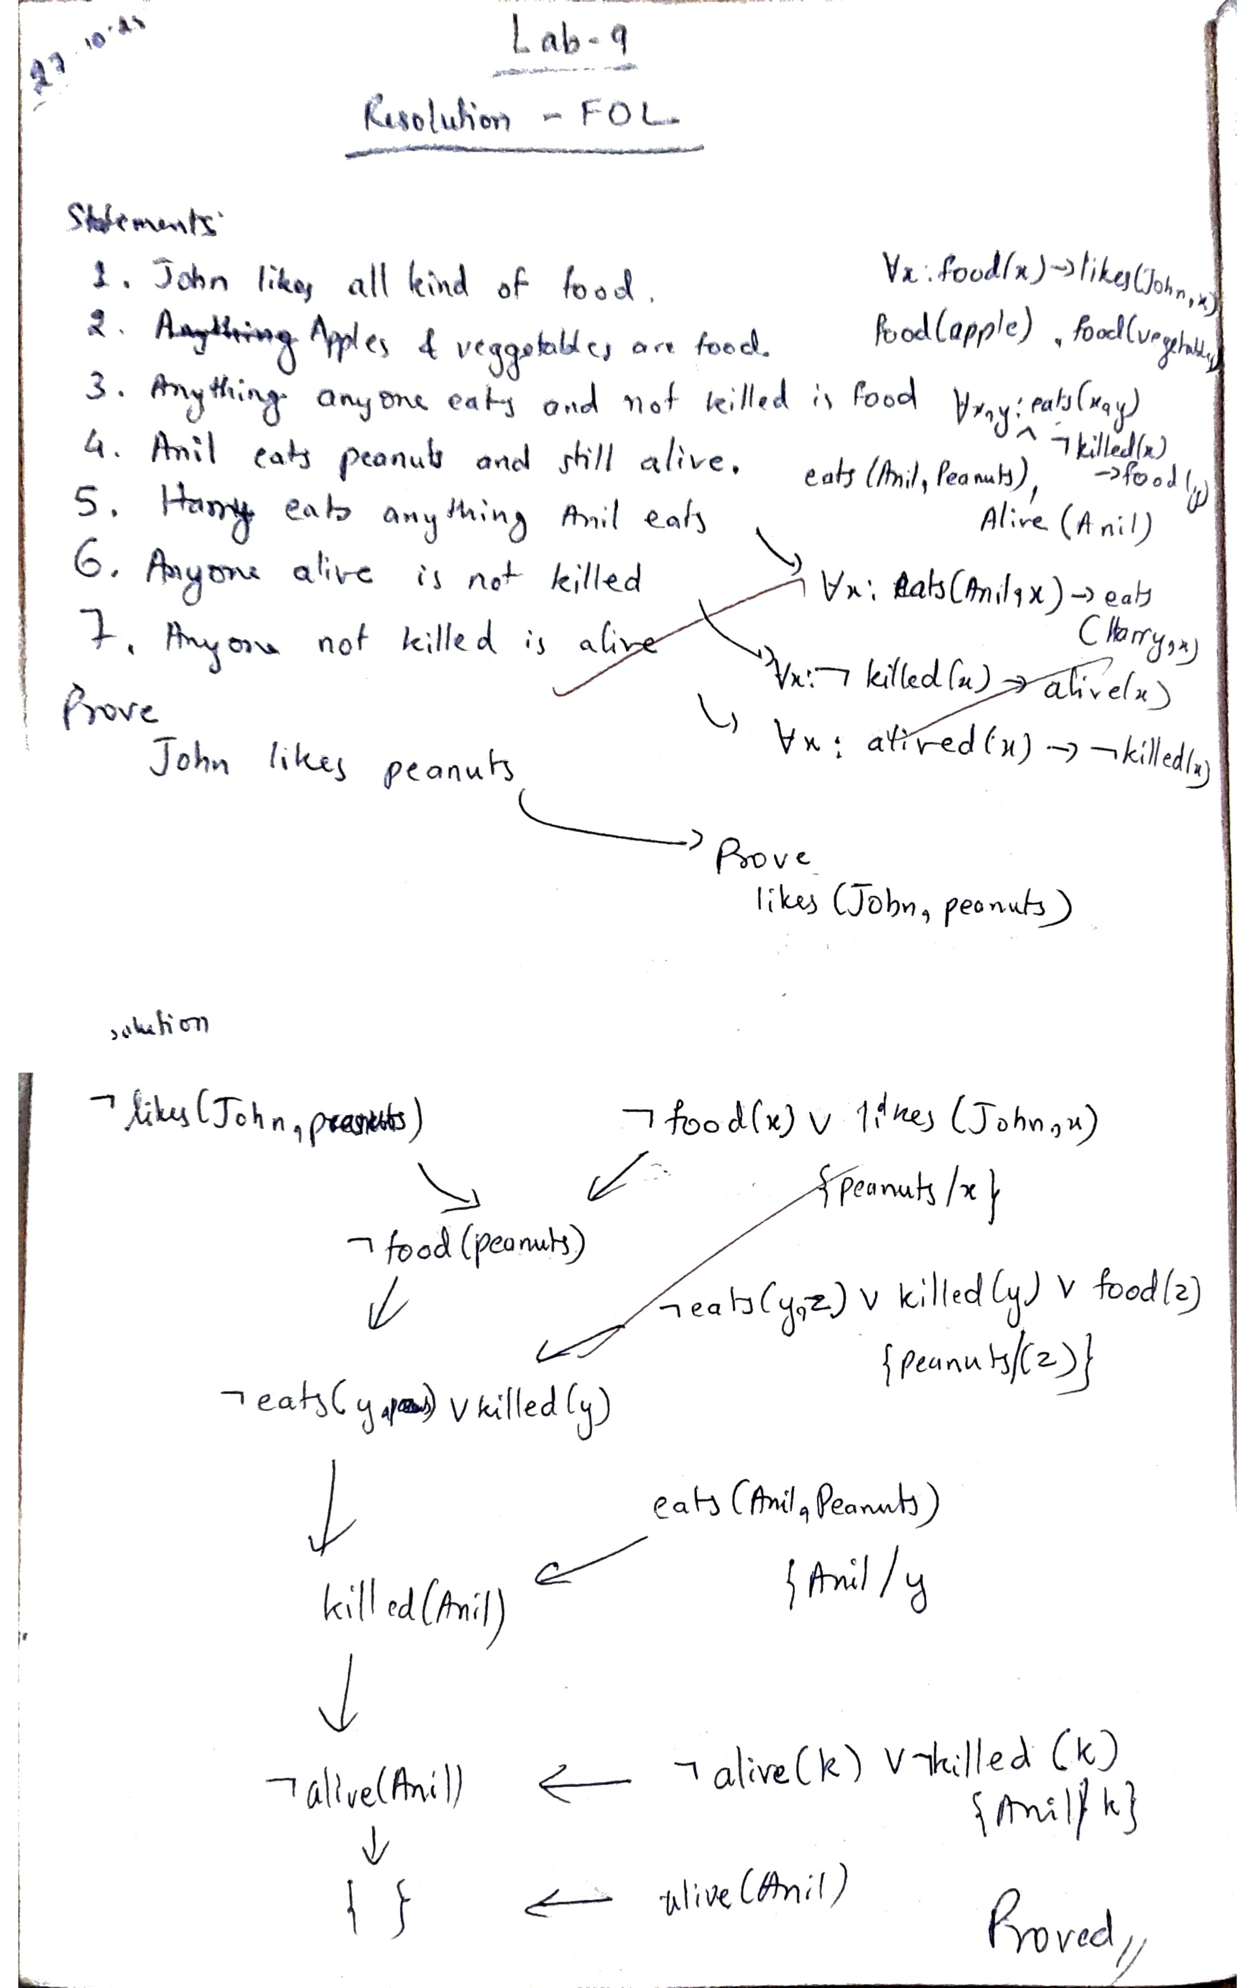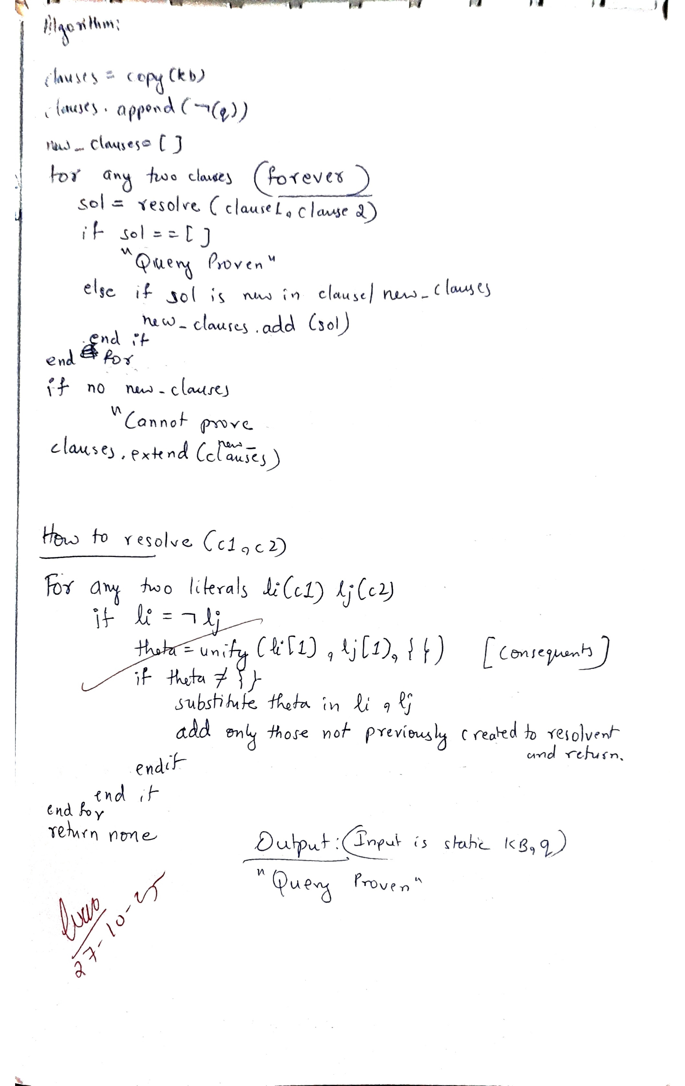

Code:
Resolution
from copy import deepcopy

def is_variable(term):
"""Check if a term is a variable (starts with lowercase)."""
return term[0].islower()

def unify(x, y, theta=None):
"""Unify two expressions with a given substitution theta."""
if theta is None:
theta = {}
if x == y:
return theta
elif is_variable(x):
return unify_var(x, y, theta)
elif is_variable(y):
return unify_var(y, x, theta)
elif isinstance(x, list) and isinstance(y, list) and len(x) == len(y):
for xi, yi in zip(x, y):
theta = unify(xi, yi, theta)
if theta is None:
return None
return theta
else:
return None

def unify_var(var, x, theta):
"""Unify variable with expression."""
# If var is a list, take its first element
if isinstance(var, list) and len(var) == 1:
var = var[0]

if isinstance(x, list) and len(x) == 1:
x = x[0]

if isinstance(var, list) or isinstance(x, list):
# Still a list? Not a simple variable; fail unification
return None

if var in theta:
return unify(theta[var], x, theta)
elif isinstance(x, str) and x in theta:
return unify(var, theta[x], theta)
elif occurs_check(var, x, theta):
return None
else:
theta = theta.copy()
theta[var] = x
return theta

def occurs_check(var, x, theta):
"""Check if variable occurs in x (prevents infinite loops)."""
if var == x:
return True
elif isinstance(x, list):
return any(occurs_check(var, xi, theta) for xi in x)
elif x in theta:
return occurs_check(var, theta[x], theta)
return False

def apply_substitution(clause, substitution):
"""Apply substitution to a clause."""
new_clause = []
for literal in clause:
pred, args = literal[0], literal[1]
new_args = []
for arg in args:
while arg in substitution:
arg = substitution[arg]
new_args.append(arg)
new_clause.append((pred, new_args))
return new_clause

def negate(literal):
"""Negate a literal (add or remove '~')."""
if literal[0].startswith('~'):
return (literal[0][1:], literal[1])
else:
return ('~' + literal[0], literal[1])

def resolve(ci, cj):
"""Try to resolve two clauses."""
for li in ci:
for lj in cj:
if li[0] == '~' + lj[0] or lj[0] == '~' + li[0]:
theta = unify(li[1], lj[1], {})
if theta is not None:
new_ci = apply_substitution(
[x for x in ci if x != li], theta)
new_cj = apply_substitution(
[x for x in cj if x != lj], theta)
resolvent = []
for lit in new_ci + new_cj:
pred, args = lit
# Convert args list → tuple for hashability
lit_hashable = (pred, tuple(args))
if lit_hashable not in [(p, tuple(a)) for (p, a) in resolvent]:
resolvent.append(lit)
return resolvent
return None

def fol_resolution(kb, query):
"""Perform resolution refutation for FOL KB ⊢ query."""
clauses = deepcopy(kb)
clauses.append([negate(query)])

print("\nInitial clauses:")
for i, c in enumerate(clauses):
print(f"C{i+1}: {c}")

while True:
new_clauses = []
for i in range(len(clauses)):
for j in range(i + 1, len(clauses)):
resolvent = resolve(clauses[i], clauses[j])
if resolvent == []:
print("\nDerived empty clause ⇒ Query proven by contradiction!")
return True
if resolvent and resolvent not in clauses and resolvent not in new_clauses:
new_clauses.append(resolvent)
if not new_clauses:
print("\nNo new clauses ⇒ Query cannot be proven.")
return False
clauses.extend(new_clauses)
print("\nNew clauses derived:")
for c in new_clauses:
print(c)

if __name__ == "__main__":
# Knowledge Base (Example)
# 1. Human(x) → Mortal(x)
# 2. Human(Socrates)
# Query: Mortal(Socrates)
# Converted to CNF:
# 1. ~Human(x) ∨ Mortal(x)
# 2. Human(Socrates)
kb = [
[('~Food', ['x']), ('Likes', ['John', 'x'])], # (a)
[('Food', ['Apple'])], # (b1)
[('Food', ['Vegetables'])], # (b2)
[('~Eats', ['x', 'y']), ('Killed', ['x']), ('Food', ['y'])], # (c)
[('Eats', ['Anil', 'Peanuts'])], # (d1)
[('Alive', ['Anil'])], # (d2)
[('~Eats', ['Anil', 'x']), ('Eats', ['Harry', 'x'])], # (e)
[('~Alive', ['x']), ('~Killed', ['x'])], # (f)
[('Killed', ['x']), ('Alive', ['x'])] # (g)
]

query = ('Likes', ['John', 'Peanuts'])

result = fol_resolution(kb, query)
print("\nResult:", "Proven" if result else "Not Proven")
print("SHASHANK SHANTHARAM NAYAK-1BM23CS313")

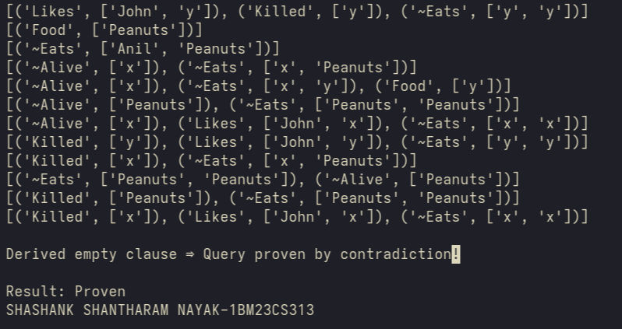
Github Link:
https://github.com/DevelSSN/1BM23CS313-SHASHANK-SHANTHARAM-NAYAK/tree/AI

Program 1
Implement Tic –Tac –Toe Game
Implement vacuum cleaner agent

Algorithm:
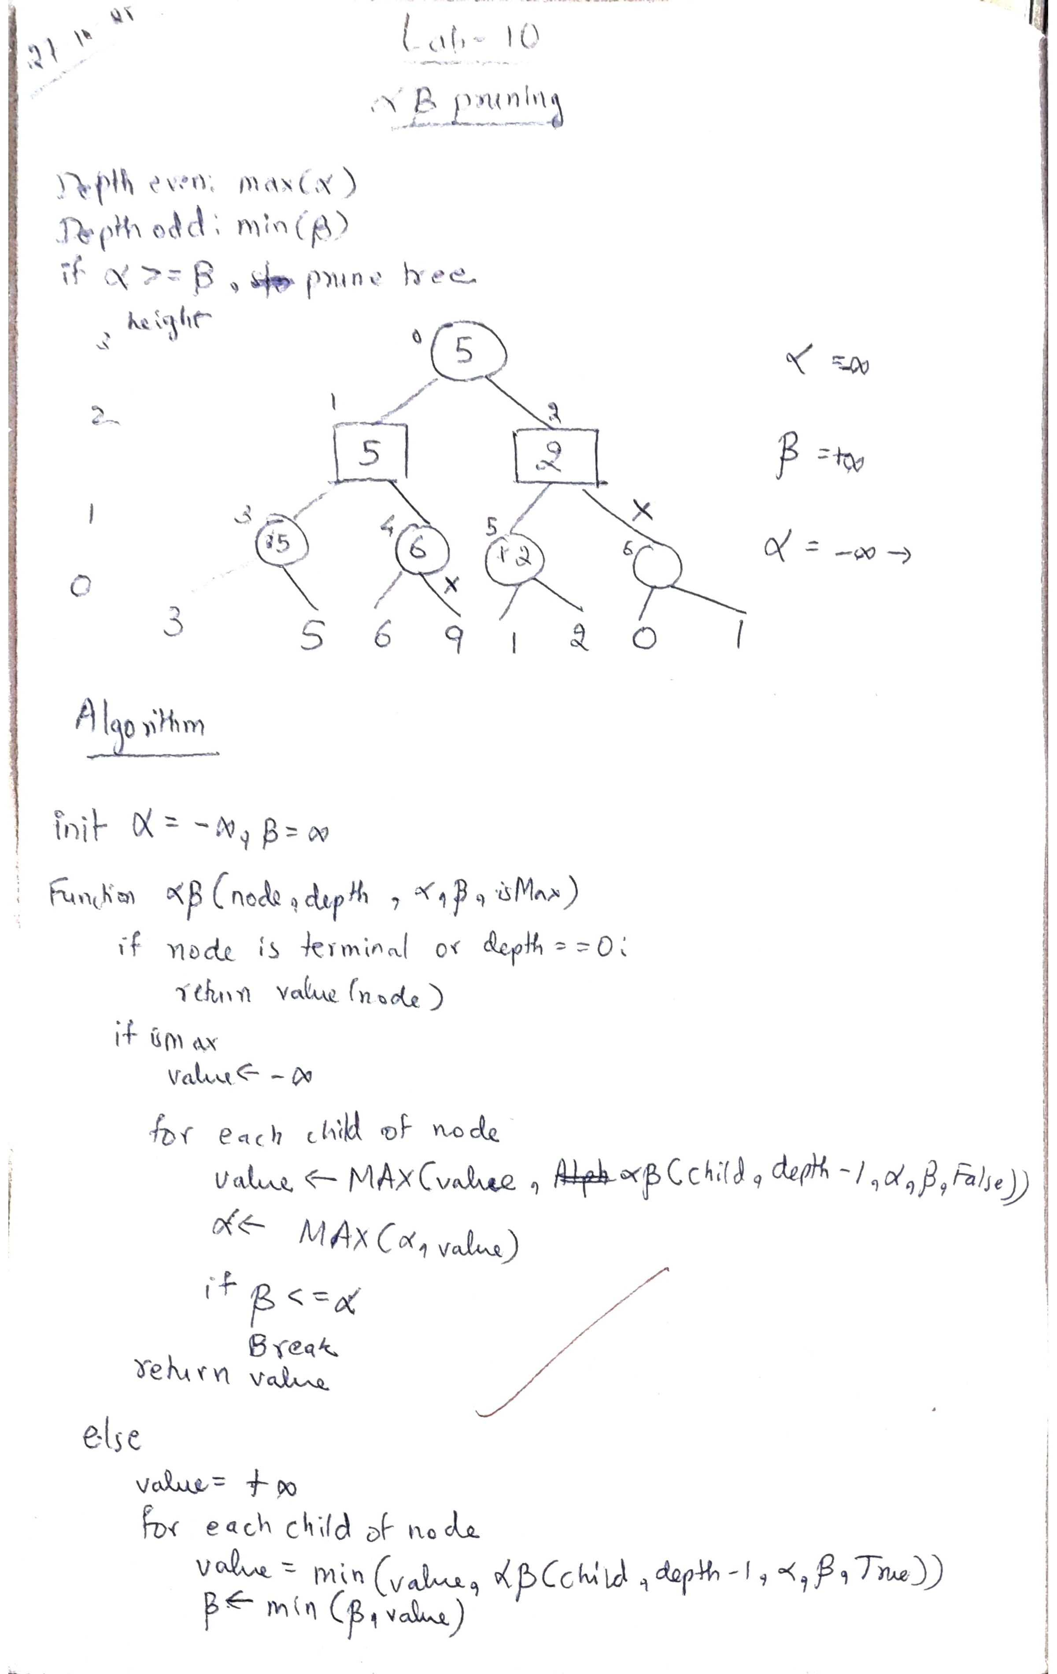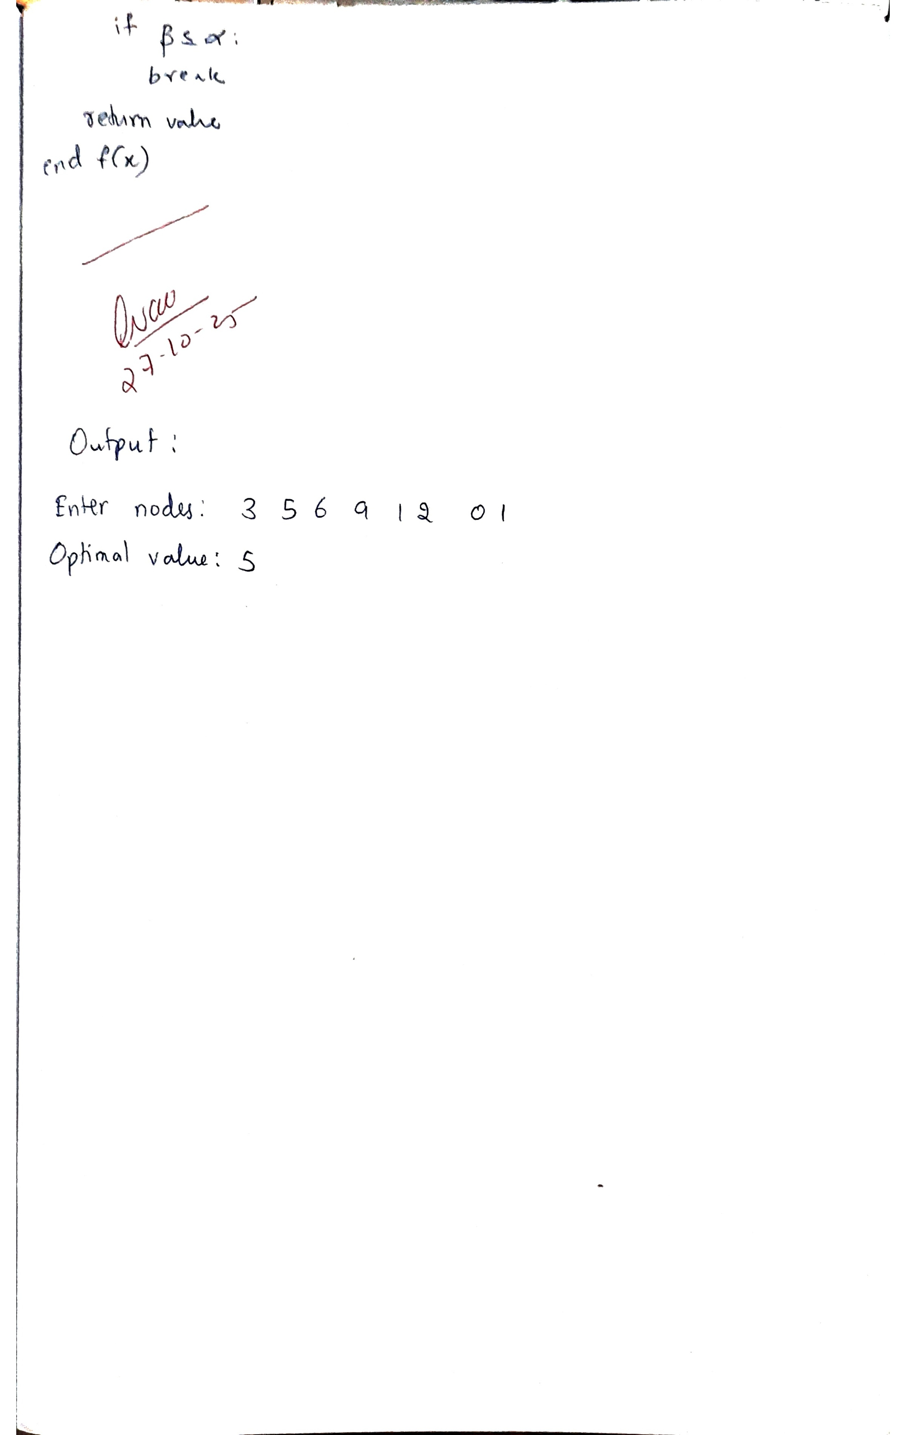

Code:
Alpha-Beta Pruning
# Alpha-Beta Pruning implementation
# Depth 0 -> MAX node
# Depth 1 -> MIN node
# and so on alternates

def alpha_beta(node, depth, alpha, beta, maximizingPlayer, values, index=0):
"""
node: current node index in tree
depth: current depth of tree
alpha: best value MAX player can guarantee
beta: best value MIN player can guarantee
maximizingPlayer: True if MAX node, False if MIN node
values: list of leaf values
index: current leaf index (for binary tree representation)
"""

# Base case — if depth == 0 or at leaf node
if depth == 0 or index >= len(values):
return values[index]

if maximizingPlayer:
# MAX node
best = float('-inf')
for i in range(2): # Two children per node
val = alpha_beta(node*2 + i + 1, depth - 1, alpha,
beta, False, values, index*2 + i)
best = max(best, val)
alpha = max(alpha, best)

# Pruning condition
if beta <= alpha:
break
return best
else:
# MIN node
best = float('inf')
for i in range(2):
val = alpha_beta(node*2 + i + 1, depth - 1, alpha,
beta, True, values, index*2 + i)
best = min(best, val)
beta = min(beta, best)

# Pruning condition
if beta <= alpha:
break
return best

# Example usage:
if __name__ == "__main__":
# Example tree: 3 levels (depth = 3 -> 8 leaf nodes)
values = [3, 5, 6, 9, 1, 2, 0, 1] # Leaf node values
depth = 3 # Tree depth
alpha = float('-inf')
beta = float('inf')

print("Leaf Nodes:", values)
optimal_value = alpha_beta(0, depth, alpha, beta, True, values)
print("Optimal Value (with Alpha-Beta Pruning):", optimal_value)
print("SHASHANK SHANTHARAM NAYAK-1BM23CS313")

